What is DAC?
DAC is identity-based access control. DAC mechanisms will be controlled by user identification such as username and password. DAC is discretionary because the owners can transfer objects or any authenticated information to other users. In simple words, the owner can determine the access privileges.
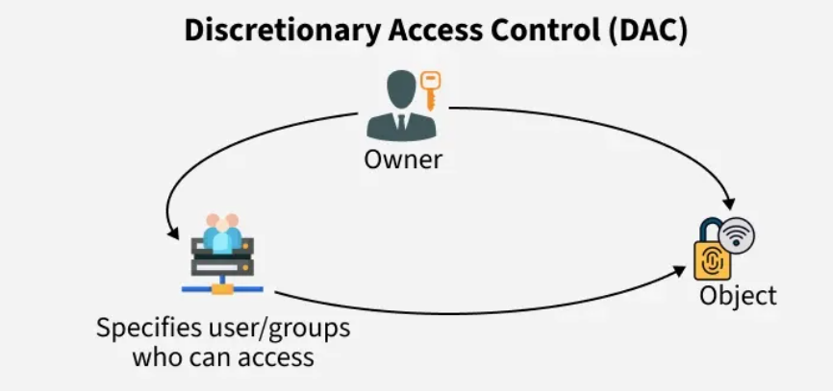DAC
Examples: Imagine your Instagram account as a host user. Once you put a story online and tag your friend, the story would only be visible to your followers. If that friend reposts it, then their followers can also view the story. This system is called DAC, where users can share objects (story files/privileges) based on authentication.

What is MAC?
The operating system in MAC will provide access to the user based on their identities and data. To gain access, the user has to submit their personal information. It is very secure because the rules and restrictions are imposed by the admin and will be strictly followed. MAC settings and policy management will be established in a secure network and are limited to system administrators.
MAC
Examples: Whereas, if you post a story to your close friends list, only those you’ve added as close friends can view the story. In this case, even the tagged person cannot repost it due to the rules and restrictions set by Instagram. This system is called MAC, where the rules and restrictions are imposed by the admin and must be strictly followed. This is a more secure network compared to DAC.

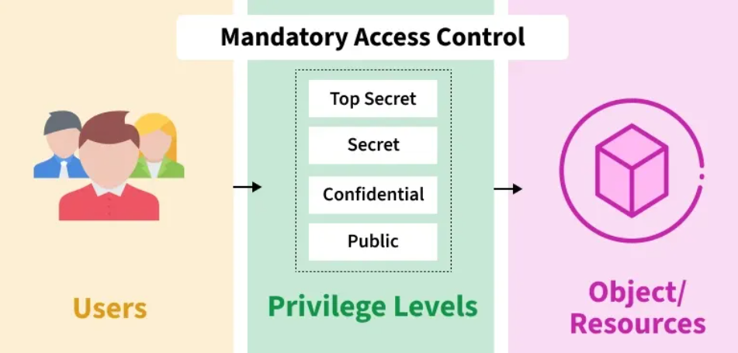
Differences Between DAC and MAC
DAC offers ease and flexibility for general use, while MAC ensures strict, high-security environments like military and government systems.

DAC | MAC
DAC stands for Discretionary Access Control. | MAC stands for Mandatory Access Control.
DAC is easier to implement. | MAC is difficult to implement.
DAC is less secure to use. | MAC is more secure to use.
In DAC, the owner can determine the access and privileges and can restrict the resources based on the identity of the users. | In MAC, the system only determines the access and the resources will be restricted based on the clearance of the subjects.
DAC has extra labor-intensive properties. | MAC has no labor-intensive property.
Users will be provided access based on their identity and not using levels. | Users will be restricted based on their power and level of hierarchy.
DAC has high flexibility with no rules and regulations. | MAC is not flexible as it contains lots of strict rules and regulations.
DAC has complete trust in users. | MAC has trust only in administrators.
Decisions will be based only on user ID and ownership. | Decisions will be based on objects and tasks, and they can have their own ids.
Information flow is impossible to control. | Information flow can be easily controlled.
DAC is supported by commercial DBMSs. | MAC is not supported by commercial DBMSs.
DAC can be applied in all domains. | MAC can be applied in the military, government, and intelligence.
DAC is vulnerable to trojan horses. | MAC prevents virus flow from a higher level to a lower level.
MAC and DAC are two important access control models which are useful in regard to various security requirements. DAC has control flexibility which is appropriate for commercial use – a major strength. But it is not as safe as the MAC addressing since the later is well defined and perfect for the security conscious networks such as the military or the government. It is crucial to make a distinction between these models in order to be able to employ the most appropriate solution for the aimed objectives.

