Shadow Paging and Logging—two important techniques used in database recovery and transaction management—with simple examples and comparisons.

🧩 1. Shadow Paging

🔍 Concept
Shadow paging avoids logging by maintaining two page tables:
- Current Page Table: used during transaction execution
- Shadow Page Table: a backup that reflects the database state before the transaction began

🛠️ How It Works
- When a transaction starts, a shadow page table is created.
- All updates are made to new copies of pages, not the originals.
- If the transaction commits, the current page table replaces the shadow page table.
- If the transaction aborts, the shadow page table is used to restore the original state.

🧪 Example
Step | Action
1 | T1 starts → Shadow Page Table created
2 | T1 updates Page 5 → creates new Page 5'
3 | T1 commits → Current Page Table replaces Shadow Page Table
4 | If T1 aborted → discard Page 5', revert to Shadow Page Table

✅ Pros
- Simple recovery: no need for logs
- Fast rollback

⚠️ Cons
- High overhead for copying pages
- Poor performance for large databases

📘 2. Logging (Write-Ahead Logging - WAL)

🔍 Concept
Logging records all changes before they’re applied to the database. This ensures recovery in case of failure.

🛠️ How It Works
- Before modifying data, a log entry is written with:
  - Transaction ID
  - Data item
  - Old value
  - New value
- If the system crashes, logs are used to redo committed transactions and undo uncommitted ones.

🧪 Example
Step | Action
1 | T2 wants to update X from 100 to 120
2 | Log: [T2, X, 100, 120] written to disk
3 | X updated to 120
4 | T2 commits → log marked as committed
5 | On crash → use log to redo or undo changes

✅ Pros
- Efficient for large systems
- Supports fine-grained recovery

⚠️ Cons
- Requires careful log management
- More complex than shadow paging
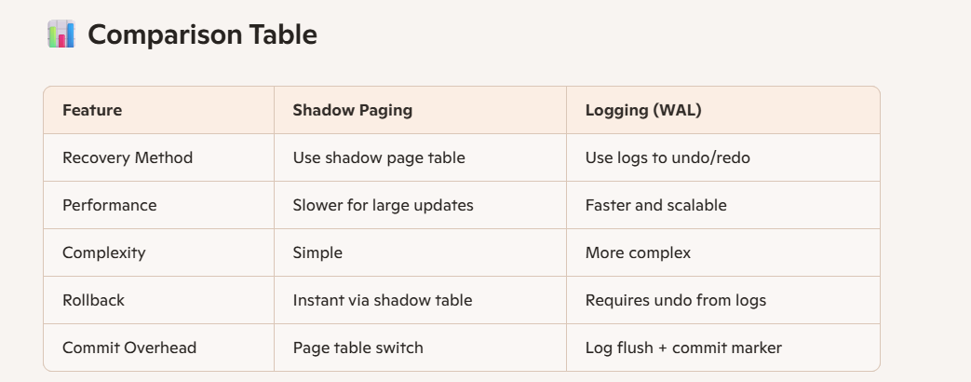
Here’s the diagram comparing Shadow Paging and Write-Ahead Logging (WAL) in database recovery:
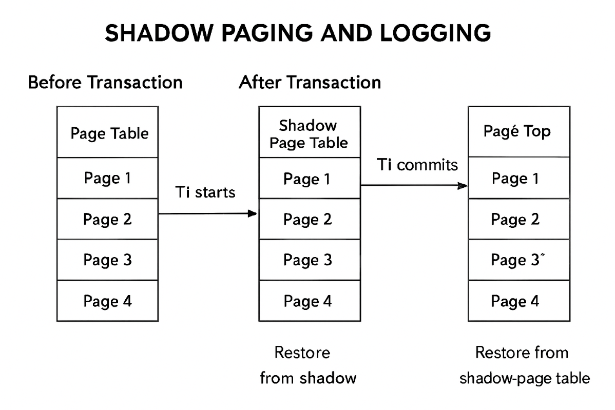

🔍 Diagram Breakdown

🔹 Shadow Paging (Left Side)
- Before Transaction: A page table points to original pages.
- During Transaction: A new page (e.g., Page 3′) is created and linked in a new page table.
- Commit: The new page table replaces the shadow page table.
- Crash Recovery: If a crash occurs before commit, the system restores from the shadow page table (no changes are lost).

🔹 Write-Ahead Logging (Right Side)
- Before Update: A log entry is written with old and new values.
- During Transaction: Changes are made to the database after logging.
- Commit: A commit record is written to the log.
- Crash Recovery:
  - Redo committed transactions using the log.
  - Undo uncommitted transactions using the log.
This visual helps highlight the copy-on-write nature of shadow paging versus the log-based redo/undo strategy of WAL.
Would you like a timeline animation or a comparison with MVCC recovery next?

