Single user system : In this at-most, only one user at a time can use the system.
Multi-user system : In the same, many users can access the system concurrently. Concurrency can be provided through :
- Interleaved Processing - In this, the concurrent execution of processes is interleaved in a single CPU. The transactions are interleaved, meaning the second transaction is started before the primary one could finish. And execution can switch between the transactions. It can also switch between multiple transactions. This causes inconsistency in the system.
- Parallel Processing - It is defined as the processing in which a large task into various smaller tasks and smaller task also executes concurrently on several nodes. In this, the processes are concurrently executed in multiple CPUs.

Transaction in DBMS
transaction is a program including a collection of database operations, executed as a logical unit (single unit)of data processing. The operations performed in a transaction include one or more of database operations like insert, delete, update or retrieve data.
read_item() − without any data update //reads data item from storage to main memory.
modify_item() − change value of item in the main memory.
write_item() − write the modified value from main memory to storage.

A transaction refers to a sequence of one or more operations (such as read, write, update, or delete) performed on the database as a single logical unit of work.
- A transaction ensures that either all the operations are successfully executed (committed) or none of them take effect (rolled back).
- Transactions are designed to maintain the integrity, consistency and reliability of the database, even in the case of system failures or concurrent access.
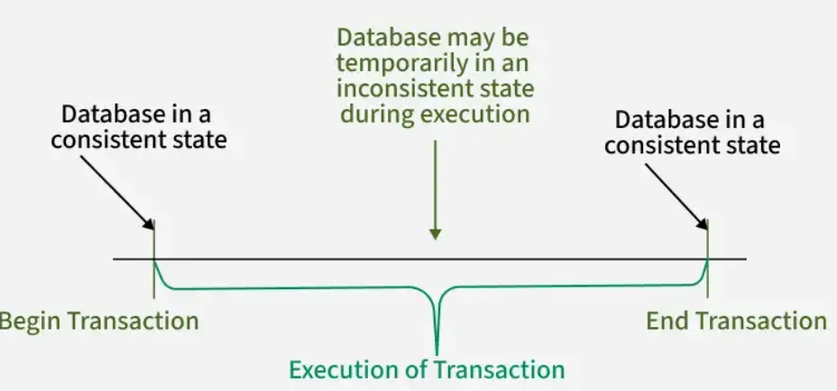

Facts about Database Transactions
- A transaction is a program unit whose execution may or may not change the contents of a database.
- The transaction is executed as a single unit.
- If the database operations do not update the database but only retrieve data, this type of transaction is called a read-only transaction.
- A successful transaction can change the database from one CONSISTENT STATE to another.
- DBMS transactions must be atomic, consistent, isolated and durable.
- If the database were in an inconsistent state before a transaction, it would remain in the inconsistent state after the transaction.

Transaction Operations
The low level operations performed in a transaction are −
- begin_transaction − A marker that specifies start of transaction execution.
- read_item or write_item − Database operations that may be interleaved with main memory operations as a part of transaction.
- end_transaction − A marker that specifies end of transaction.
- commit − A signal to specify that the transaction has been successfully completed in its entirety and will not be undone.
- rollback − A signal to specify that the transaction has been unsuccessful and so all temporary changes in the database are undone. A committed transaction cannot be rolled back.
Transaction States
A transaction may go through a subset of five states, active, partially committed, committed, failed and aborted.
- Active − The initial state where the transaction enters is the active state. The transaction remains in this state while it is executing read, write or other operations.
- Partially Committed − The transaction enters this state after the last statement of the transaction has been executed.
- Committed − The transaction enters this state after successful completion of the transaction and system checks have issued commit signal.
- Failed − The transaction goes from partially committed state or active state to failed state when it is discovered that normal execution can no longer proceed or system checks fail.
- Aborted − This is the state after the transaction has been rolled back after failure and the database has been restored to its state that was before the transaction began.
The following state transition diagram depicts the states in the transaction and the low level transaction operations that causes change in states.
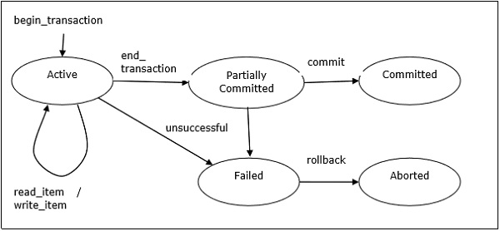
Desirable Properties of Transactions
Any transaction must maintain the ACID properties, viz. Atomicity, Consistency, Isolation, and Durability.
- Atomicity − This property states that a transaction is an atomic unit of processing, that is, either it is performed in its entirety or not performed at all. No partial update should exist.
- Consistency − A transaction should take the database from one consistent state to another consistent state. It should not adversely affect any data item in the database.
- Isolation − A transaction should be executed as if it is the only one in the system. There should not be any interference from the other concurrent transactions that are simultaneously running.
- Durability − If a committed transaction brings about a change, that change should be durable in the database and not lost in case of any failure.
Schedules and Conflicts
In a system with a number of simultaneous transactions, a schedule is the total order of execution of operations. Given a schedule S comprising of n transactions, say T1, T2, T3..Tn; for any transaction Ti, the operations in Ti must execute as laid down in the schedule S.
Types of Schedules
There are two types of schedules −
- Serial Schedules − In a serial schedule, at any point of time, only one transaction is active, i.e. there is no overlapping of transactions. This is depicted in the following graph −
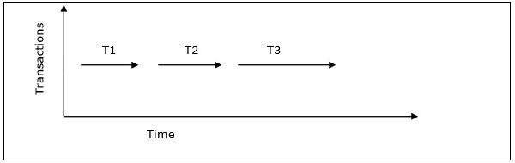
- Parallel Schedules − In parallel schedules, more than one transactions are active simultaneously, i.e. the transactions contain operations that overlap at time. This is depicted in the following graph −
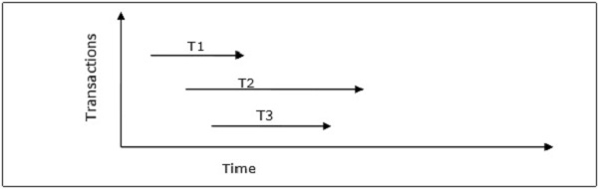
Conflicts in Schedules
In a schedule comprising of multiple transactions, a conflict occurs when two active transactions perform non-compatible operations. Two operations are said to be in conflict, when all of the following three conditions exists simultaneously −
- The two operations are parts of different transactions.
- Both the operations access the same data item.
- At least one of the operations is a write_item() operation, i.e. it tries to modify the data item.
Serializability

Operations of Transaction
A user can make different types of requests to access and modify the contents of a database. So, we have different types of operations relating to a transaction. They are discussed as follows:

1) Read(X)
A read operation is used to read the value of a particular database element X and stores it in a temporary buffer in the main memory for further actions such as displaying that value.
Example: For a banking system, when a user checks their balance, a Read operation is performed on their account balance:
SELECT balance FROM accounts WHERE account_id = 'A123';
This updates the balance of the user's account after withdrawal.

2) Write(X)
A write operation stores updated data from main memory back to the database. It usually follows a read, where data is fetched, modified (e.g., arithmetic changes) and then written back to save the updated value.
Example: For the banking system, if a user withdraws money, a Write operation is performed after the balance is updated:
UPDATE accounts SET balance = balance - 100 WHERE account_id = 'A123';
This updates the balance of the user’s account after withdrawal.

3) Commit
This operation in transactions is used to maintain integrity in the database. Due to some failure of power, hardware, or software, etc., a transaction might get interrupted before all its operations are completed. This may cause ambiguity in the database, i.e. it might get inconsistent before and after the transaction.
Example: After a successful money transfer in a banking system, a Commit operation finalizes the transaction:
COMMIT;
Once the transaction is committed, the changes to the database are permanent and the transaction is considered successful.

4) Rollback
A rollback undoes all changes made by a transaction if an error occurs, restoring the database to its last consistent state. It helps prevent data inconsistency and ensures safety.
Example: Suppose during the money transfer process, the system encounters an issue, like insufficient funds in the sender’s account. In that case, the transaction is rolled back:
ROLLBACK;
This will undo all the operations performed so far and ensure that the database remains consistent.

ACID Properties in DBMS

Transactions are fundamental operations that allow us to modify and retrieve data. However, to ensure the integrity of a database, it is important that these transactions are executed in a way that maintains consistency, correctness, and reliability even in case of failures / errors. This is where the ACID properties come into play.
ACID stands for Atomicity, Consistency, Isolation, and Durability.
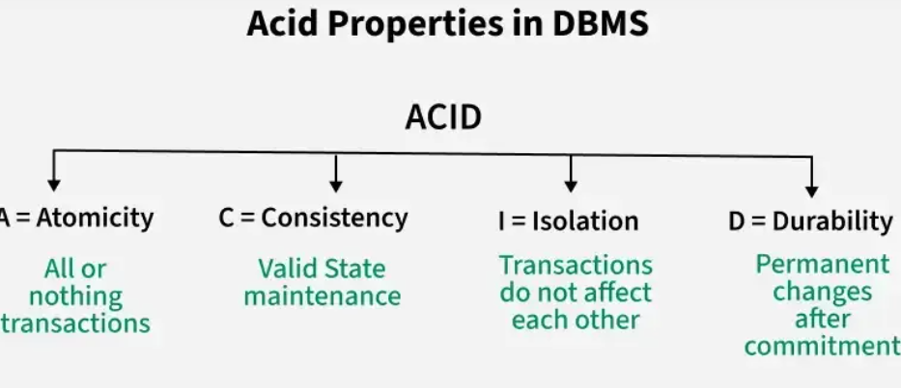

There are Four Properties of ACID

1. Atomicity
Atomicity means a transaction is all-or-nothing either all its operations succeed, or none are applied. If any part fails, the entire transaction is rolled back to keep the database consistent.
- Commit: If the transaction is successful, the changes are permanently applied.
- Abort/Rollback: If the transaction fails, any changes made during the transaction are discarded.
Example: Consider the following transaction T consisting of T1 and T2 : Transfer of $100 from account X to account Y .

2. Consistency
Consistency in transactions means that the database must remain in a valid state before and after a transaction.
- A valid state follows all defined rules, constraints, and relationships (like primary keys, foreign keys, etc.).
- If a transaction violates any of these rules, it is rolled back to prevent corrupt or invalid data.
- If a transaction deducts money from one account but doesn't add it to another (in a transfer), it violates consistency.

3. Isolation
Isolation ensures that transactions run independently without affecting each other. Changes made by one transaction are not visible to others until they are committed.
It ensures that the result of concurrent transactions is the same as if they were run one after another, preventing issues like:
- Dirty reads: reading uncommitted data
- Non-repeatable reads: data changes between two reads
- Phantom reads: new rows appear during a transaction

4. Durability:
Durability ensures that once a transaction is committed, its changes are permanently saved, even if the system fails. The data is stored in non-volatile memory, so the database can recover to its last committed state without losing data.
Example: After successfully transferring money from Account A to Account B, the changes are stored on disk. Even if there is a crash immediately after the commit, the transfer details will still be intact when the system recovers, ensuring durability.

How ACID Properties Impact DBMS Design and Operation
The ACID properties, in totality, provide a mechanism to ensure the correctness and consistency of a database in a way such that each transaction is a group of operations that acts as a single unit, produces consistent results, acts in isolation from other operations, and updates that it makes are durably stored.

1. Data Integrity and Consistency
ACID properties safeguard the data integrity of a DBMS by ensuring that transactions either complete successfully or leave no trace if interrupted. They prevent partial updates from corrupting the data and ensure that the database transitions only between valid states.

2. Concurrency Control
ACID properties provide a solid framework for managing concurrent transactions. Isolation ensures that transactions do not interfere with each other, preventing data anomalies such as lost updates, temporary inconsistency, and uncommitted data.

3. Recovery and Fault Tolerance
Durability ensures that even if a system crashes, the database can recover to a consistent state. Thanks to the Atomicity and Durability properties, if a transaction fails midway, the database remains in a consistent state.

Critical Use Cases for ACID in Databases
In modern applications, ensuring the reliability and consistency of data is crucial. ACID properties are fundamental in sectors like:
- Banking: Transactions involving money transfers, deposits, or withdrawals must maintain strict consistency and durability to prevent errors and fraud.
- E-commerce: Ensuring that inventory counts, orders, and customer details are handled correctly and consistently, even during high traffic, requires ACID compliance.
- Healthcare: Patient records, test results, and prescriptions must adhere to strict consistency, integrity, and security standards.
ACID Properties in DBMS - GeeksforGeeks

Types of Schedules in DBMS

Scheduling is the process of determining the order in which transactions are executed. When multiple transactions run concurrently, scheduling ensures that operations are executed in a way that prevents conflicts or overlaps between them.
There are several types of schedules, all of them are depicted in the diagram below:
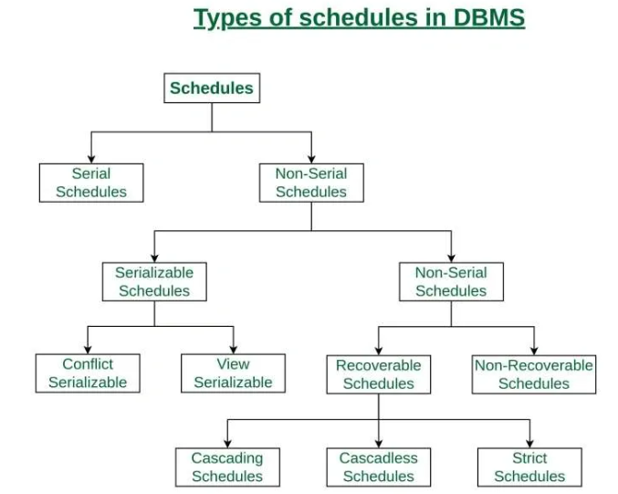

Serial Schedule
Schedules in which the transactions are executed non-interleaved, i.e., a serial schedule is one in which no transaction starts until a running transaction has ended are called serial schedules. Example: Consider the following schedule involving two transactions T1 and T2 .
T1 | T2
R(A)
W(A)
R(B)
 | W(B)
 | R(A)
 | R(B)
where R(A) denotes that a read operation is performed on some data item 'A' This is a serial schedule since the transactions perform serially in the order T1 —> T2

Non-Serial Schedule
This is a type of Scheduling where the operations of multiple transactions are interleaved. This might lead to a rise in the concurrency problem. The transactions are executed in a non-serial manner, keeping the end result correct and same as the serial schedule. This sort of schedule does not provide any benefit of the concurrent transaction.

Serializability (parallel/ side by side/ but in a serial- sequence- concurrency control)

A serializable schedule of n transactions is a parallel schedule which is equivalent to a serial schedule comprising of the same n transactions. A serializable schedule contains the correctness of serial schedule while ascertaining better CPU utilization of parallel schedule.

Equivalence of Schedules

Equivalence of two schedules can be of the following types −

Result equivalence − Two schedules producing identical results are said to be result equivalent.

View equivalence − Two schedules that perform similar action in a similar manner are said to be view equivalent.

Conflict equivalence − Two schedules are said to be conflict equivalent if both contain the same set of transactions and has the same order of conflicting pairs of operations.

It can be of two types namely,

1.Serializable Scheduling (Concurrency Control)
- Ensures database consistency in non-serial schedules by verifying if they behave like serial schedules.
- In a serial schedule, transactions execute one after another, ensuring correctness without conflicts.
- Non-serial schedules allow concurrent transactions but must be serializable to maintain correctness.

Why Serializable?
- Prevents anomalies due to concurrent execution.
- Allows better CPU and resource utilization.
- Improves throughput without sacrificing consistency.

Two types of serializable scheduling are:

i. Conflict Serializable: Conflict Serializability ensures that a concurrent schedule produces the same result as some serial execution by reordering non-conflicting operations (transaction having one write() operation atleast). It maintains data consistency and is stricter than View Serializability, which allows more flexibility but still preserves correctness.
A schedule is called conflict serializable if it can be transformed into a serial schedule by swapping non-conflicting operations.

Non-conflicting operations: Two operations are considered non-conflicting if they operate on separate data items, or if they involve the same data item but both are read operations.

Conflicting Operations
Two operations are said to be conflicting if all conditions are satisfied:
- They belong to different transactions
- They operate on the same data item
- Atleast one of them is a write operation

Two operations are said to be conflicting if all conditions satisfy:
- They belong to different transactions
- They operate on the same data item
- At Least one of them is a write operation

Consider the following schedule:
S1: R1(A), W1(A), R2(A), W2(A), R1(B), W1(B), R2(B), W2(B)
get two transactions of schedule S1:
T1: R1(A), W1(A), R1(B), W1(B)
T2: R2(A), W2(A), R2(B), W2(B)
Swapping non-conflicting operations R2(A) and R1(B) in S1, the schedule becomes,
S11: R1(A), W1(A), R1(B), W2(A), R2(A), W1(B), R2(B), W2(B)
-> Similarly, swapping non-conflicting operations W2(A) and W1(B) in S11, the schedule becomes,
S12: R1(A), W1(A), R1(B), W1(B), R2(A), W2(A), R2(B), W2(B)

ii. View Serializable:
Serial or one by one execution of schedules has less resource utilization and low throughput. To improve it, two or more transactions are run concurrently.
- View Serializability guarantees that even though transactions run concurrently, their outcome will be identical to the result achieved if the transactions were executed one by one in a specific order.
- 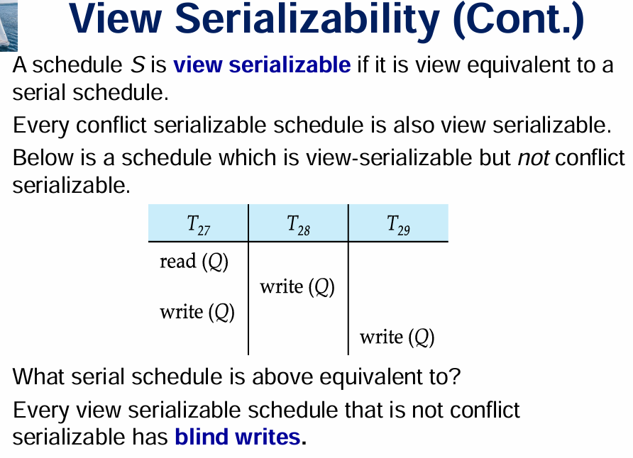
- It is a concept in concurrency control that determines whether a non-serial schedule can be rearranged to act like a serial schedule without conflicts.
- It ensures data consistency and integrity when multiple transactions are executed at the same time.

View Serializable and View Equivalent
A schedule is view serializable if it is view equivalent to a serial schedule. In simple terms:
- Serial Schedule: Transactions are executed one after another without interleaving.
- View Equivalent: Two schedules are view equivalent if they produce the same final state of the database and ensure the same read/write behavior for all transactions.
A schedule S1 is said to be view-equivalent to a schedule S2 if and only if:
While conflict serializability strictly enforces the order of conflicting operations (like reads and writes on the same data), view equivalence focuses on ensuring that the outcome of the schedule is identical to that of a serial schedule, regardless of the exact operation order.

A Schedule is called view serializable if it is view equal to a serial schedule (no overlapping transactions).

2. Non-Serializable Scheduling
Schedules that do not preserve serial equivalence and may lead to inconsistencies if not handled carefully.

i. Recoverable Schedule: Schedules in which transactions commit only after all transactions whose changes they read commit are called recoverable schedules. In other words, if some transaction T j is reading value updated or written by some other transaction Ti , then the commit of Tj must occur after the commit of Ti .
Example: Consider the following schedule involving two transactions T1 and T2 .
T1 | T2
R(A)
W(A)
 | W(A)
 | R(A)
commit
 | commit
This is a recoverable schedule since T1 commits before T2 , that makes the value read by T2 correct. There can be three types of recoverable schedule:
ii. Cascading Schedule: Also called Avoids cascading aborts/rollbacks (ACA). When there is a failure in one transaction and this leads to the rolling back or aborting other dependent transactions, then such scheduling is referred to as Cascading rollback or cascading abort. Example: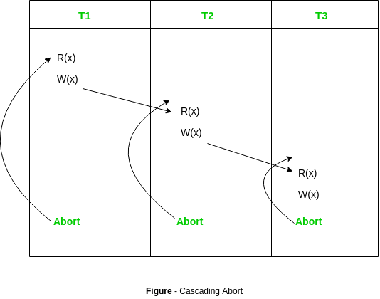

Strict Schedule: A schedule is strict if for any two transactions Ti , Tj , if a write operation of Ti precedes a conflicting operation of Tj (either read or write), then the commit or abort event of Ti also precedes that conflicting operation of Tj . In other words, Tj can read or write updated or written value of Ti only after Ti commits/aborts.
Example: Consider the following schedule involving two transactions T1 and T2 .
T1 | T2
R(A)
 | R(A)
W(A)
commit | (write operation aftr T1 commit)
 | W(A)
 | R(A)
 | commit
This is a strict schedule since T2 reads and writes A which is written by T1 only after the commit of T1 .
v. Non-Recoverable Schedule: Example: Consider the following schedule involving two transactions T1 and T2 .
T1 | T2
R(A)
W(A)
 | W(A)
 | R(A)
 | commit
abort
T2 read the value of A written by T1, and committed. T1 later aborted, therefore the value read by T2 is wrong, but since T2 committed, this schedule is non-recoverable.
Note - It can be seen that:
- Cascadeless schedules are stricter than recoverable schedules or are a subset of recoverable schedules.
- Strict schedules are stricter than cascadeless schedules or are a subset of cascadeless schedules.
- Serial schedules satisfy constraints of all recoverable, cascadeless and strict schedules and hence is a subset of strict schedules.
The relation between various types of schedules can be depicted as:
