Mod8 Dbms | PDF | Databases | Data Warehouse for all types of databases unit 4-advanced topics
Distributed Databases
AU: Dec.-04,07,16,17,19, May-03,06,14,16,17,19, Marks 16
Definition of distributed databases:
• A distributed database system consists of loosely coupled sites (computer) that share no physical components and each site is associated a database system.
• The software that maintains and manages the working of distributed databases is called distributed database management system.
• The database system that runs on each site is independent of each other. Refer Fig. 5.1.1.
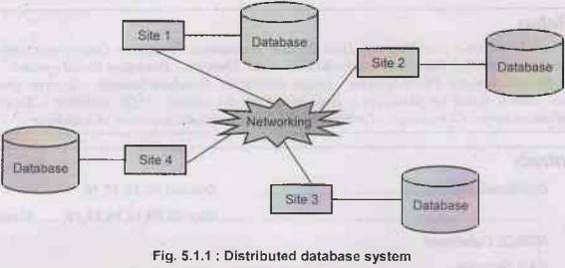
The transactions can access data at one or more sites.
Advantages of distributed database system
(1) There is fast data processing as several sites participate in request processing. 2.
(2) Reliability and availability of this system is high.
(3) It possess reduced operating cost.
(4) It is easier to expand the system by adding more sites.
(5) It has improved sharing ability and local autonomy.
Disadvantages of distributed database system
(1) The system becomes complex to manage and control.
(2) The security issues must be carefully managed.
(3) The system require deadlock handling during the transaction processing otherwise the entire system may be in inconsistent state.
(4) There is need of some standardization for processing of distributed database system.
Difference between distributed DBMS and centralized DBMS
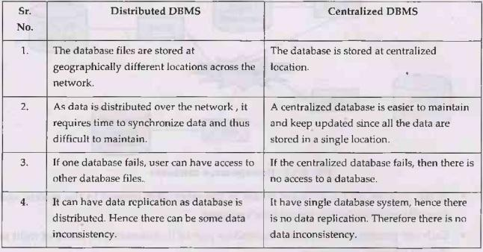
Uses of distributed system:
(1) Often distributed databases are used by organizations that have numerous offices in different geographical locations. Typically an individual branch is interacting primarily with the data that pertain to its own operations, with a much less frequent need for general company data. In such a situation, distributed systems are useful.
(2) Using distributed system, one can give permissions to single sections of the overall database, for better internal and external protection.
(3) If we need to add a new location to a business, it is simple to create an additional node within the database, making distribution highly scalable.
Types of Distributed Databases
There are two types of distributed databases -
(1) Homogeneous databases
• The homogeneous databases are kind of database systems in which all sites have identical software running on them. Refer Fig. 5.1.2.
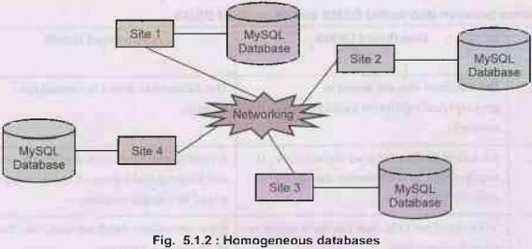
• In this system, all the sites are aware of the other sites present in the system and they all cooperate in processing user's request.
• Each site present in the system, surrenders part of its autonomy in terms of right to change schemas or software.
• The homogeneous database system appears as a single system to the user.
(2) Heterogeneous databases
• The heterogeneous databases are kind of database systems in which different sites have different schema or software. Refer Fig. 5.1.3.
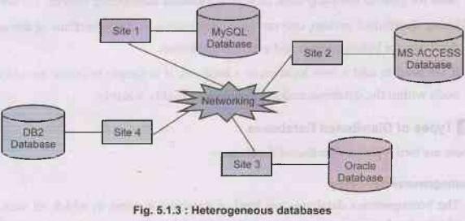
• The participating sites are not aware of other sites present in the system.
• These sites provide limited facilities for cooperation in transaction processing.
Architecture
• Following is an architecture of distributed databases. In this architecture the local database is maintained by each site.
• Each site is interconnected by communication network.
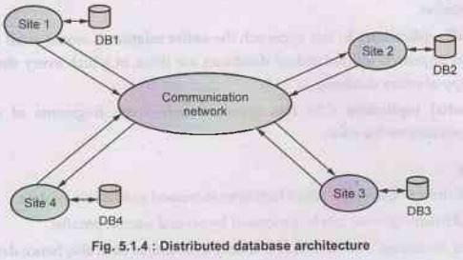
When user makes a request for particular data at site Si then it is first searched at the local database. If the data is not present in the local database then the request for that data is passed to all the other sites via communication network. Each site then searches for that data at its local database. When data is found at particular site say Sj then it is transmitted to site Si via communication network.
Data Storage
There are two approaches of storing relation r in distributed database -
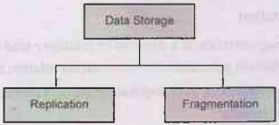
(1) Replication: System maintains multiple copies of data, stored in different sites, for grind faster retrieval and fault tolerance.
(2) Fragmentation: Relation is partitioned into several fragments stored in distinct sites.
Data Replication
• Concept: Data replication means storing a copy or replica of a relation fragments in two or more sites.
• There are two methods of data replication replication. (1) Full replication (2) Partial replication
• Full replication: In this approach the entire relation is stored at all the sites. In this approach full redundant databases are those in which every site contains a copy of entire database.
• Partial replication: In this approach only some fragments of relation are replicated on the sites.
Advantages:
(1) Availability: Data replication facilitates increased availability of data.
(2) Parallelism: Queries can be processed by several sites in parallel.
(3) Faster accessing: The relation r is locally available at each site, hence data accessing becomes faster.
Disadvantages:poi
(1) Increased cost of update: The major disadvantage of data replication is increased betcost of updated. That means each replica of relation r must be updated from all the sites if user makes a request for some updates in relation.
(2) Increased complexity in concurrency control: It becomes complex to implement the concurrency control mechanism for all the sites containing replica.
Data Fragmentation
• Concept: Data fragmentation is a division of relation r into fragments r1,r2, r3,...,rn which contain sufficient information to reconstruct relation r.
• There are two approaches of data fragmentation - (1) Horizontal fragmentation and (2) Vertical fragmentation.
• Horizontal fragmentation: In this approach, each tuple of r is assigned to one or more fragments. If relation R is fragmented in r1 and r2 fragments, then to bring these fragments back to R we must use union operation. That means R=r1ur2
• Vertical fragmentation: In this approach, the relation r is fragmented based on one or more columns. If relation R is fragmented into r1 and r2 fragments using vertical fragmentation then to bring these fragments back to original relation R we must use join operation. That means R= r1 r2
• For example - Consider following relation r
Student(RollNo, Marks, City)
The values in this schema are inserted as
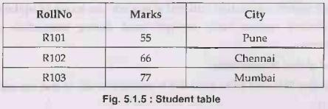
Horizontal Fragmentation 1:
SELECT * FROM Student WHERE Marks >50 AND City='Pune'
We will get
Horizontal Fragmentation 2:
SELECT * FROM Student WHERE Marks >50 AND City="Mumbai'
We will get

Vertical Fragmentation 1 :
SELECT * FROM RollNo
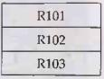
Vertical Fragmentation 2:
SELECT * FROM city
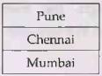
Transaction Processing
Basic Concepts
In distributed system transaction initiated at one site can access or update data at other sites. Let us discuss various basic concepts used during transaction processing in distributed systems -
• Local and global transactions :
Local transaction Ti is said to be local if it is initiated at site Si and can access or update data at site Si only.
Global transaction Ti initiated by site Si is said to be global if it can access or update data at site Si, Sj,Sk and so on.
• Coordinating and participating sites:
The site at which the transaction is initiated is called coordinating site. The participating sites are those sites at which the sub-transactions are executing. For example - If site S1 initiates the transaction T1 then it is called coordinating site. Now assume that transaction T1 (initiated at S1) can access site S2 and S3. Then sites S2 and S3 are called participating sites.
To access the data on site S2, the transaction T1 needs another transaction T12 on site S2 similarly to access the data on site S3, the transaction T2 needs some transaction say T13 on site S3. Then transactions T12 and T13 are called sub-transactions. The above described scenario can be represented by following Fig. 5.1.6.
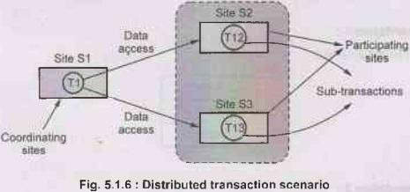
• Transaction manager :
The transaction manager manages the execution of those transactions (or subtransactions) that access data stored in a local site.
(1) To maintain the log for recovery purpose.
(2) Participating in coordinating the concurrent execution of the transactions executing balls at that site.
• Transaction coordinator:
The transaction coordinator coordinates the execution of the various transactions (both local and global) initiated at that site.
The tasks of Transaction coordinator are -
(1) Starting the execution of transactions that originate at the site.
(2) Distributing subtransactions at appropriate sites for execution
Let TC denotes the transaction coordinator and TM denotes the transaction manager, then the system architecture can be represented as,
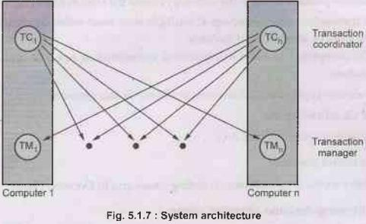
Failure Modes
There are four types of failure modes,
1. Failure of site
2. Loss of messages
3. Failure of communication link
4. Network partition
The most common type of failure in distributed system is loss or corruption of messages. The system uses Transmission Control Protocol(TCP) to handle such error. This is a standard connection oriented protocol in which message is transmitted from one end to another using wired connection.
• If two nodes are not directly connected, messages from one to another must be routed through sequence of communication links. If the communication link fails, the messages are rerouted by alternative links.
• A system is partitioned if it has been split into two subsystems. This is called partitions. Lack of connection between the subsystems also cause failure in distributed system.
Commit Protocols
Two Phase Commit Protocol
• The atomicity is an important property of any transaction processing. What is this atomicity property? This property means either the transaction will execute completely or it won't execute at all.
• The commit protocol ensures the atomicity across the sites in following ways -
i) A transaction which executes at multiple sites must either be committed at all the sites, or aborted at all the sites.
ii) Not acceptable to have a transaction committed at one site and aborted at another.
• There are two types of important sites involving in this protocol -
• One Coordinating site
• One or more participating sites.
Two phase commit protocol
This protocol works in two phases - i) Voting phase and ii) Decision phase.
Phase 1: Obtaining decision or voting phase
Step 1: Coordinator site Ci asks all participants to prepare to commit transaction Ti.
• Ci adds the records <prepareT> to the log and writes the log to stable storage.
• It then sends prepare T messages to all participating sites at which T will get executed.
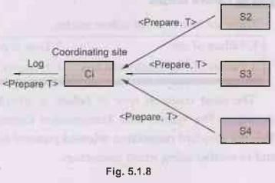
Step 2: Upon receiving message, transaction manager at participating site determines if it can commit the transaction
• If not, add a record <no T> to the log and send abort T message to coordinating site Ci.
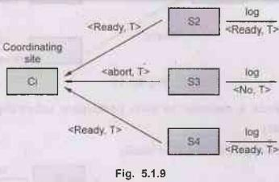
• If the transaction can be committed, then :
• Add the record <ready T> to the log
• Force all records for T to stable storage
• Send ready T message to Ci.
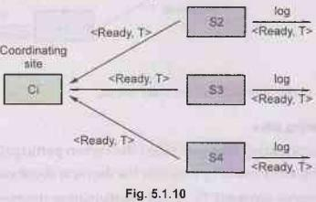
Phase 2: Recoding decision phase
• T can be committed of Ci received a ready T message from all the participating sites otherwise T must be aborted.o
• Coordinator adds a decision record, <commit T> or <abort T>, to the log and forces record onto stable storage. Once the record stable storage it is irrevocable (even if failures occur)
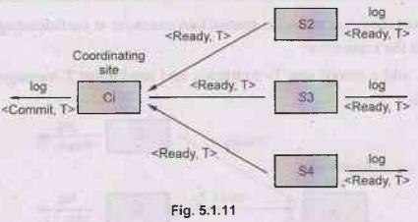
• Coordinator sends a message to each participant informing it of the decision
(commit or abort)
• Participants take appropriate action locally.
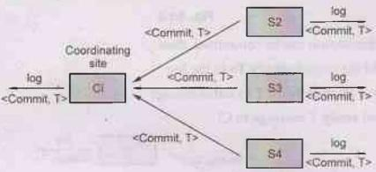
Failure of site
There are various cases at which failure may occur,
(1) Failure of participating sites
• If any of the participating sites gets failed then when participating site Si recovers, it examines the log entry made by it to take the decision about executing transaction.
• If the log contains <commit T> record: participating site executes redo (T)
• If the log contains <abort T> record: participating site executes undo (T)
• If the log contains <ready T> record: participating site must consult Coordinating site to take decision about execution of transaction T.
• If T committed, redo (T)
• If T aborted, undo (T)
• If the log of participating site contains no record then that means Si gets failed before responding to Prepare T message from coordinating site. In this case it must abort T
(2) Failure of coordinator
• If coordinator fails while the commit protocol for T is executing then participating sites must take decision about execution of transaction T:
i) If an active participating site contains a <commit T> record in its log, then T site must be committed.
ii) If an active participating site contains an <abort T> record in its log, then T must be aborted.
iii) If some active participating site does not contain a <ready T> record in its log, then the failed coordinator Ci cannot have decided to commit T. Can therefore abort T.
iv) If none of the above cases holds, then all participating active sites must have a <ready T> record in their logs, but no additional control records (such as <abort T> of <commit T>). In this case active sites must wait for coordinator site Ci to recover, to find decision.
Two phase locking protocol has blocking problem.
What is blocking problem?
It is a stage at which active participating sites may have to wait for failed coordinator site to recover.
The solution to this problem is to use three phase locking protocol.
Three Phase Commit Protocol
• The three phase locking is an extension of two phase locking protocol in which eliminates the blocking problem.
• Various assumptions that are made for three phase commit protocol are -
• No network partitioning.
• At any point at least one site must be up.
• At the most k sites (participating as well as coordinating) can fail.
• Phase 1: This phase is similar to phase 1 of two phase protocol. That means Coordinator site Ci asks all participants to prepare to commit transaction Ti. The coordinator then makes the decision about commit or abort based on the response from all the participating sites.
• Phase 2: In phase 2 coordinator makes a decision as in 2 Phase Commit which is called the pre-commit decision <Pre-commit, T>, and records it in multiple (at least K) participating sites.
• Phase 3: In phase 3, coordinator sends commit/abort message to all participating Brits sites.
• Under three phase protocol, the knowledge of pre-commit decision can be used to commit despite coordinator site failure. That means if the coordinating site in case gets failed then one of the participating site becomes the coordinating site and der consults other participating sites to know the Pre-commit message which they possess. Thus using this pre-commit t message the decision about commit/abort is taken by this new coordinating site.
• This protocol avoids blocking problem as long as less than k sites fail.
Advantage of three phase commit protocol
(1) It avoid blocking problem.
Disadvantage of three phase commit protocol
(1) The overhead is increased.
Query Processing and Optimization
Distributed database query is processed using following steps-
(1) Query Mapping:
• The input query on distributed data is specified using query language.
• This query language is then translated into algebraic query.
• During this translation the global conceptual schema is referred.
• During the translation some important actions such as normalization, analysis for semantic errors, simplification are carried out then input query is restructured into algebraic query.
(2) Localization:
• In this step, the replication of information is handled.
• The distributed query is mapped on the global schema to separate queries on individual fragments.
(3) Global Query Optimization: optimization means selecting a strategy from list of candidate queries which is closest to optimal. For optimization, the cost is computed. The total cost is combination of CPU cost, I/O cost and communication costs.
(4) Local Query Optimization: This step is common to all sites in distributed database. The techniques of local query optimization are similar to those used in centralized systems.
Review Questions
1. What are the various features of distributed database versus centralized database system? AU: Dec.-17, Marks 6, May-17, Marks 8
2. Explain the architecture of a distributed database. AU: Dec.-16, Marks 7
3. Explain about distributed databases and their characteristics, functions and advantages and disadvantages. AU: Dec.-07, May-14, Marks 8, May-16, Marks 16
4. Explain design of distributed database. AU: Dec.-04, Marks 8

