Joins in DBMS
Joins in DBMS - GeeksforGeeks

Join is an operation in DBMS(Database Management System) that combines the rows of two or more tables based on related columns between them. The main purpose of join is to retrieve the data from multiple tables in other words Join is used to perform multi-table queries. It is denoted by ⨝.
- Combines rows from two tables where the condition in the ON clause is satisfied.
- Only matching rows are included in the result.

Syntax
R3 <- ⨝(R1) <join_condition> (R2)
where R1 and R2 are two relations to be joined and R3 is a relation that will hold the result of the join operation.

Example:
Copy codeSELECT A.column1, B.column2
FROM TableA A
INNER JOIN TableB B
ON A.common_column = B.common_column;

Example
Temp <- ⨝(student) S.roll=E.roll(Exam)
where S and E are aliases of the student and exam respectively.

JOIN Example
Consider the two tables below as follows:
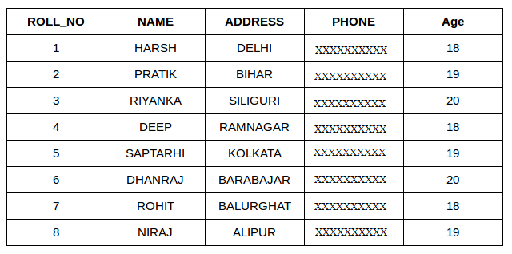Table 1 - Student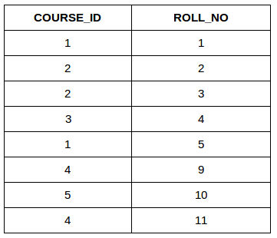Table 2 - Student_Course
Both these tables are connected by one common key (column) i.e. ROLL_NO.
We can perform a JOIN operation using the given relational algebra:
Student ⨝ Student_course
Output:
ROLL_NO | NAME | ADDRESS | PHONE | AGE | COURSE_ID
1 | HARSH | DELHI | xxxxxxxxxx | 18 | 1
2 | PRATIK | BIHAR | xxxxxxxxxx | 19 | 2
3 | PRIYANKA | SILIGURI | xxxxxxxxxx | 20 | 2
4 | DEEP | RAMNAGAR | xxxxxxxxxx | 18 | 3
5 | SAPTARHI | KOLKATA | xxxxxxxxxx | 19 | 1

Types of Join
There are many types of Joins in SQL. Depending on the use case, you can use different types of SQL JOIN clauses. Here are the frequently used SQL JOIN types:

1. Inner Join
Inner Join is a join operation in DBMS that combines two or more tables based on related columns and returns only rows that have matching values among tables. Inner join has two types.
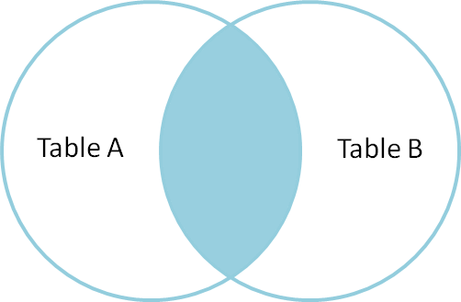Inner Join

Inner Join
Inner Join is used to return rows from both tables which satisfy the given condition. It is the most widely used join operation and can be considered as a default join-type
An Inner join or equijoin is a comparator-based join which uses equality comparisons in the join-predicate. However, if you use other comparison operators like “>” it can’t be called equijoin.
Inner Join further divided into three subtypes:
- Theta join
- Natural join
- EQUI join

Theta Join
Theta Join allows you to merge two tables based on the condition represented by theta. Theta joins work for all comparison operators. It is denoted by symbol θ. The general case of JOIN operation is called a Theta join.

- Conditional join/ Theta join
- Equi Join
- Natural Join

(a) Conditional Join
Conditional join or Theta join is a type of inner join in which tables are combined based on the specified condition.
In conditional join, the join condition can include <, >, <=, >=, ≠ operators in addition to the '=' operator.

Example: Suppose two tables A and B
Table A
R | S
10 | 5
7 | 20
Table B
T | U
10 | 12
17 | 6
A ⨝ S<T B
Output
R | S | T | U
10 | 5 | 10 | 12

Consider the following tables.
Table A |  |  | Table B
column 1 | column 2 |  | column 1 | column 2
1 | 1 |  | 1 | 1
1 | 2 |  | 1 | 3
For example:
A ⋈ _{A.column 2 > B.column 2} (B)
A ⋈ A.column 2 > B.column 2 (B)
column 1 | column 2
1 | 2

Explanation: This query joins the table A, B and projects attributes R, S, T, U were the condition S < T is satisfied.

(b) Equi Join
Equi Join is a type of inner join where the join condition uses the equality operator ('=') between columns.

A ⋈ A.column 2 = B.column 2 (B)
column 1 | column 2
1 | 1

Example: Suppose there are two tables Table A and Table C
Table A
Column A | Column B
a | a
a | b
Table C
Column A | Column B
a | a
a | c
A ⨝ A.Column B = C.Column B (C)
Output
Column A | Column B
a | a
Explanation: The data value "a" is available in both tables Hence we write that "a" is the table in the given output.

(c) Natural Join
Natural join is a type of inner join in which we do not need any comparison operators. In natural join, columns should have the same name and domain. There should be at least one common attribute between the two tables.
Natural Join does not utilize any of the comparison operators. In this type of join, the attributes should have the same name and domain. In Natural Join, there should be at least one common attribute between two relations.
It performs selection forming equality on those attributes which appear in both relations and eliminates the duplicate attributes.
Example:
Consider the following two tables
C
Num | Square
2 | 4
3 | 9

D
Num | Cube
2 | 8
3 | 18
C ⋈ D
C ⋈ D
Num | Square | Cube
2 | 4 | 8
3 | 9

Example: Suppose there are two tables Table A and Table B
Table A
Number | Square
2 | 4
3 | 9
Table B
Number | Cube
2 | 8
3 | 27
A ⨝ B
Output
Number | Square | Cube
2 | 4 | 8
3 | 9 | 27
Explanation - Column Number is available in both tables Hence we write the "Number column once " after combining both tables.

2. Outer Join
Outer join is a type of join that retrieves matching as well as non-matching records from related tables. There are three types of outer join
- Left outer join
- Right outer join
- Full outer join

(a) Left Outer Join
It is also called left join. This type of outer join retrieves all records from the left table and retrieves matching records from the right table.

eft Outer Join returns all the rows from the table on the left even if no matching rows have been found in the table on the right. When no matching record is found in the table on the right, NULL is returned.
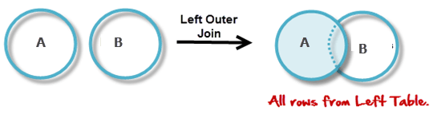
Consider the following 2 Tables
A
Num | Square
2 | 4
3 | 9
4 | 16

B
Num | Cube
2 | 8
3 | 18
5 | 75
A B
A ⋈ B
Num | Square | Cube
2 | 4 | 8
3 | 9 | 18
4 | 16 | –

Example: Suppose there are two tables Table A and Table B

- Returns all rows from the left table and the matching rows from the right table.
- If no match is found, NULL values are returned for columns from the right table.
- Example:
Copy codeSELECT A.column1, B.column2
FROM TableA A
LEFT JOIN TableB B
ON A.common_column = B.common_column;

Table A
Number | Square
2 | 4
3 | 9
4 | 16
Table B
Number | Cube
2 | 8
3 | 27
5 | 125
A ⟕ B
Output
Number | Square | Cube
2 | 4 | 8
3 | 9 | 27
4 | 16 | NULL
Explanation: Since we know in the left outer join we take all the columns from the left table (Here Table A) In the table A we can see that there is no Cube value for number 4. so we mark this as NULL.

(b) Right Outer Join
It is also called a right join. This type of outer join retrieves all records from the right table and retrieves matching records from the left table. And for the record which doesn't lies in Left table will be marked as NULL in result Set.
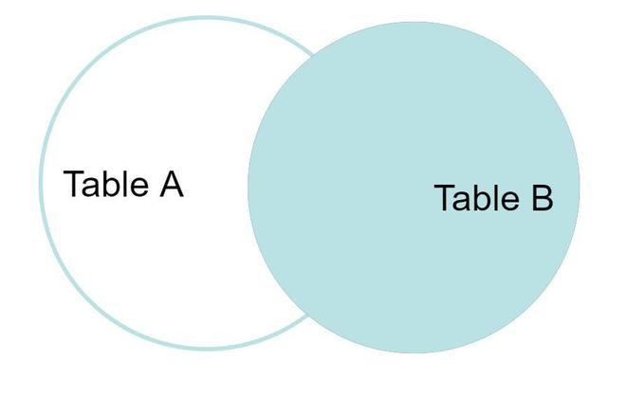Right Outer Join

- Returns all rows from the right table and the matching rows from the left table.
- If no match is found, NULL values are returned for columns from the left table.
- Right Outer Join returns all the columns from the table on the right even if no matching rows have been found in the table on the left. Where no matches have been found in the table on the left, NULL is returned. RIGHT outer JOIN is the opposite of LEFT JOIN
- In our example, let’s assume that you need to get the names of members and movies rented by them. Now we have a new member who has not rented any movie yet.
- 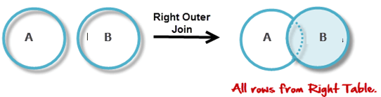
- A B
A ⋈ B
Num | Cube | Square
2 | 8 | 4
3 | 18 | 9
5 | 75 | –
- Example:
Copy codeSELECT A.column1, B.column2
FROM TableA A
RIGHT JOIN TableB B
ON A.common_column = B.common_column;

Example: Suppose there are two tables Table A and Table B
A ⟖ B
Output:
Number | Square | Cube
2 | 4 | 8
3 | 9 | 27
5 | NULL | 125
Explanation: Since we know in the right outer join we take all the columns from the right table (Here Table B) In table A we can see that there is no square value for number 5. So we mark this as NULL.

(c) Full Outer Join
FULL JOIN creates the result set by combining the results of both LEFT JOIN and RIGHT JOIN. The result set will contain all the rows from both tables. For the rows for which there is no matching, the result set will contain NULL values.
Example: Table A and Table B are the same as in the left outer join
A ⟗ B
Output:
Number | Square | Cube
2 | 4 | 8
3 | 9 | 27
4 | 16 | NULL
5 | NULL | 125

In a Full Outer Join , all tuples from both relations are included in the result, irrespective of the matching condition.
Example:
A B
A ⋈ B
Num | Square | Cube
2 | 4 | 8
3 | 9 | 18
4 | 16 | –
5 | – | 75

Explanation: Since we know in full outer join we take all the columns from both tables (Here Table A and Table B) In the table A and Table B we can see that there is no Cube value for number 4 and No Square value for 5 so we mark this as NULL.
- Full Join (Full Outer Join):
  - Combines the results of both Left and Right Joins.
  - Returns all rows from both tables, with NULLs in place where there is no match.
  - Example:
Copy codeSELECT A.column1, B.column2
FROM TableA A
FULL JOIN TableB B
ON A.common_column = B.common_column;

- Cross Join:
  - Produces the Cartesian product of two tables.
  - Every row from the first table is paired with every row from the second table.
  - Example:
Copy codeSELECT A.column1, B.column2
FROM TableA A
CROSS JOIN TableB B;

Must go through SQL JOIN - Tpoint Tech
- Self Join:
  - A table is joined with itself.
  - Useful for hierarchical or recursive relationships.
  - Example:
Copy codeSELECT A.column1, B.column2
FROM TableA A, TableA B
WHERE A.common_column = B.common_column;

Must go through SQL JOIN - Tpoint Tech

Key Points
- Joins are used to retrieve data from multiple tables in a relational database.
- The type of join determines how unmatched rows are handled.
- Proper indexing on the columns used in joins can significantly improve query performance.

Different Types of SQL JOINs
Here are the different types of the JOINs in SQL:
- (INNER) JOIN: Returns records that have matching values in both tables
- LEFT (OUTER) JOIN: Returns all records from the left table, and the matched records from the right table
- RIGHT (OUTER) JOIN: Returns all records from the right table, and the matched records from the left table
- FULL (OUTER) JOIN: Returns all records when there is a match in either left or right table
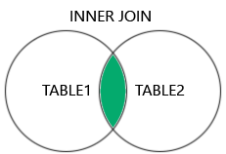 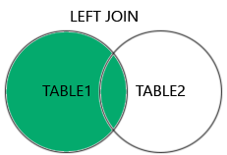 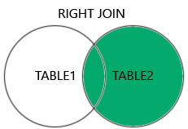 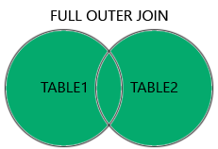SQL Joins

Summary
- There are mainly two types of joins in DBMS 1) Inner Join 2) Outer Join
- An inner join is the widely used join operation and can be considered as a default join-type.
- Inner Join is further divided into three subtypes: 1) Theta join 2) Natural join 3) EQUI join
- Theta Join allows you to merge two tables based on the condition represented by theta
- When a theta join uses only equivalence condition, it becomes an equi join.
- Natural join does not utilize any of the comparison operators.
- An outer join doesn’t require each record in the two join tables to have a matching record.
- Outer Join is further divided into three subtypes are: 1)Left Outer Join 2) Right Outer Join 3) Full Outer Join
- The LEFT Outer Join returns all the rows from the table on the left, even if no matching rows have been found in the table on the right.
- The RIGHT Outer Join returns all the columns from the table on the right, even if no matching rows have been found in the table on the left.
- In a full outer join, all tuples from both relations are included in the result, irrespective of the matching condition.
For SQL coding: SQL JOIN (With Examples)
SQL JOIN - Tpoint Tech

