Introduction to Database Normalization
From: Introduction to Database Normalization - GeeksforGeeks
Normalization in SQL (1NF - 5NF): A Beginner’s Guide | DataCamp
For more readings : Normalization in SQL and DBMS (1NF - 6NF): Complete Guide
Normalization in DBMS: 1NF, 2NF, 3NF, and BCNF [Examples]
Normalization in DBMS: 1NF, 2NF, 3NF and BCNF in Database

What is Normalization, in this context, It is the process of organizing data within a database (relational database) to eliminate data anomalies, such as redundancy.
In simpler terms, it involves breaking down a large, complex table into smaller and simpler tables while maintaining data relationships.
Normalization is commonly used when dealing with large datasets.
Database Normalization is a database design technique that reduces data redundancy and eliminates undesirable characteristics like Insertion, Update and Deletion Anomalies. Normalization rules divides larger tables into smaller tables and links them using relationships. The purpose of Normalization in SQL is to eliminate redundant (repetitive) data and ensure data is stored logically.
It standardizes data across various fields, from databases to data analysis and machine learning, improving accuracy and consistency.
Retrieved From: Data Normalization Explained: Types, Examples, & Methods | Estuary
The inventor of the relational model Edgar Codd proposed the theory of normalization of data with the introduction of the First Normal Form, and he continued to extend theory with Second and Third Normal Form. Later he joined Raymond F. Boyce to develop the theory of Boyce-Codd Normal Form.

some scenarios where normalization is often used:

Data integrity
Imagine a database that contains customer information. Without normalization, if a customer changes their age, we would need to update it in multiple places, which would increase the risk of inconsistencies. By normalizing the data, we can have separate tables linked by a unique identifier that will ensure that the data remains accurate and consistent.

Efficiency querying
Let’s consider a complex database with multiple related tables that stores redundant information. In this scenario, queries involving joins become more complicated and resource-intensive. Normalization will help simplify querying by breaking down data into smaller tables, with each table containing only relevant information, thereby reducing the need for complex joins.

Storage optimization
A major problem with redundant data is that it occupies unnecessary storage space. For instance, if we store the same product details in every order record, it leads to duplication. With normalization, you can eliminate redundancy by splitting data into separate tables.

Why is Normalization in SQL Important?
Normalization is an important process in database design that helps improve the database's efficiency, consistency, and accuracy. It makes it easier to manage and maintain the data and ensures that the database is adaptable to changing business needs.
- Reduces redundancy: Redundancy is when the same information is stored multiple times, and a good way of avoiding this is by splitting data into smaller tables.
- Improves query performance: You can perform faster query execution on smaller tables that have undergone normalization.
- Minimizes update anomalies: With normalized tables, you can easily update data without affecting other records.
- Enhances data integrity: It ensures that data remains consistent and accurate.
—--------------------------------------------
- Database normalization is the process of organizing the attributes of the database to reduce or eliminate data redundancy (having the same data but at different places).
- Data redundancy unnecessarily increases the size of the database as the same data is repeated in many places. Inconsistency problems also arise during insert, delete, and update operations.
- In the relational model, there exist standard methods to quantify how efficient a databases is. These methods are called normal forms and there are algorithms to covert a given database into normal forms.
- Normalization generally involves splitting a table into multiple ones which must be linked each time a query is made requiring data from the split tables.
—---------------------------------------------

Why do we need Normalization?
The primary objective for normalizing the relations is to eliminate the below anomalies. Failure to reduce anomalies results in data redundancy, which may threaten data integrity and cause additional issues as the database increases. Normalization consists of a set of procedures that assist you in developing an effective database structure.
- Insertion Anomalies: Insertion anomalies occur when it is not possible to insert data into a database because the required fields are missing or because the data is incomplete. For example, if a database requires that every record has a primary key, but no value is provided for a particular record, it cannot be inserted into the database.
- Deletion anomalies: Deletion anomalies occur when deleting a record from a database and can result in the unintentional loss of data. For example, if a database contains information about customers and orders, deleting a customer record may also delete all the orders associated with that customer.
- Updation anomalies: Updation anomalies occur when modifying data in a database and can result in inconsistencies or errors. For example, if a database contains information about employees and their salaries, updating an employee’s salary in one record but not in all related records could lead to incorrect calculations and reporting.
- Difficulty in managing relationships: It becomes more challenging to maintain complex relationships in an unnormalized structure.
- Other factors that drive the need for normalization are partial dependencies and transitive dependencies, in which partial dependencies can lead to data redundancy and update anomalies, and transitive dependencies can lead to data anomalies. We will be looking at how these dependencies can be dealt with to ensure database normalization in the coming sections.

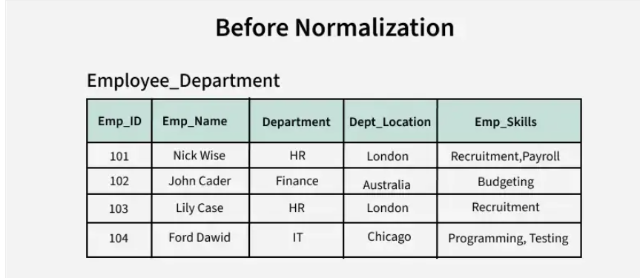
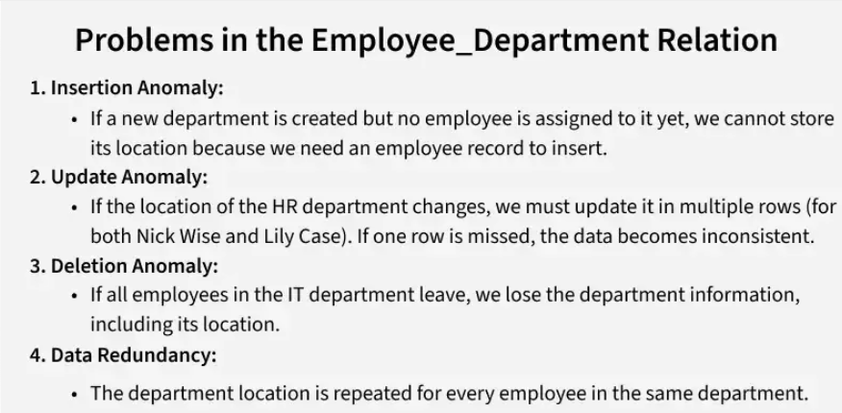

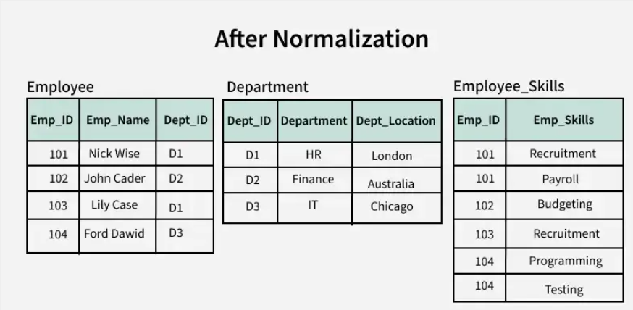
Before Normalization: The table is prone to redundancy and anomalies (insertion, update, and deletion).
After Normalization: The data is divided into logical tables to ensure consistency, avoid redundancy and remove anomalies making the database efficient and reliable.

The primary goal of data normalization is to add, delete, and modify data without causing data inconsistencies. It ensures that each data item is stored in only one place which reduces the overall disk space requirement and improves the consistency and reliability of the system.
In databases, it organizes fields and tables and in data analysis and machine learning, normalization is used to preprocess data before being used in any analysis.

Who Needs Data Normalization?
Data normalization has applications in a wide array of fields and professions. Its ability to streamline data storage, reduce data input error, and ensure consistency makes it an invaluable asset for anyone dealing with large datasets. Let’s discuss some of its use cases.

Data Normalization In Machine Learning
Data normalization is a standard preprocessing step in machine learning. ML engineers use it to standardize and scale their data which is very important to ensure that every feature has an equal impact on the prediction.

Data Normalization In Research
Researchers, particularly those in the field of science and engineering, often use data normalization in their work. Whether they're dealing with experimental data or large datasets, normalization helps to simplify their data, making it easier to analyze and interpret. They use it to eliminate potential distortions caused by differing scales or units and ensure that their findings are accurate and reliable.

Data Normalization In Business
In the business world, data normalization is often used in business intelligence and decision-making. Business analysts use normalization to prepare data for analysis, helping them to identify trends, make comparisons, and draw meaningful conclusions.
This helps in more informed business decisions and strategies to drive growth and success. Normalization also improves data consistency which results in better collaboration between different teams within the company.

Understanding Data Anomalies (Causes and Effects)

What Are Data Anomalies?
Data anomalies refer to inconsistencies or errors that occur when you deal with stored data. These anomalies can compromise the integrity of the data and cause inaccuracies that do not reflect the real-world scenario the data is meant to represent.
In databases, anomalies are typically because of redundancy or poor table construction. In data analysis and machine learning, anomalies can arise from missing values, incorrect data types, or unrealistic values.
Regardless of the context, anomalies can significantly impact the consistency and integrity of data. They can cause inaccurate analyses, misleading results, and poor decision-making. Therefore, identifying and addressing data anomalies is a crucial step in any data-driven process.

Causes and Effects of Data Anomalies
Data anomalies can be categorized based on their causes and their impact. They primarily affect databases and data analysis/machine learning systems, leading to inefficiencies and unreliable outputs. Each type can disrupt data consistency and affect operations.

Exploring Data Anomalies: A Focus on Databases, Data Analysis & Machine Learning
Data anomalies can originate from a range of sources and their impact can vary, often causing substantial complications if not addressed properly. Let’s talk about 2 broad categories where these anomalies are most prevalent and can cause major issues.
1. Anomalies In Databases
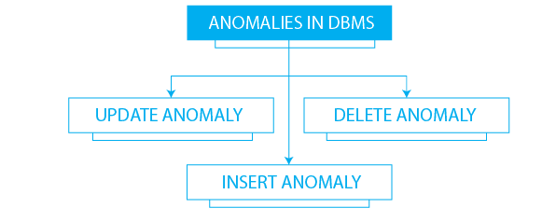
Image Source
When it comes to databases, 3 primary types of data anomalies result from update, insertion, and deletion operations.
- Insertion anomalies: These occur when the addition of new data to the database is hindered because of the absence of other necessary data. This situation often arises in systems where specific dependencies between data elements exist.
- Update anomalies: This type of anomalies happen when modifications to the data end up causing inconsistencies. This usually occurs when the same piece of data is stored in multiple locations and changes aren't reflected uniformly across all instances.
- Deletion anomalies: You encounter these anomalies when you unintentionally lose other valuable information while removing certain data. This typically happens when multiple pieces of information are stored together and the deletion of one affects the others.
While the above anomalies are mainly related to the operations in databases and their design flaws, understand that anomalies are not limited to these aspects alone. They can very well be present in the data itself and can be a source of misleading analysis and interpretations. Let’s discuss these next.
2. Anomalies In Data Analysis & Machine Learning
In data analysis and machine learning, data anomalies can manifest as discrepancies in the values, types, or completeness of data which can significantly impact the outcome of analyses or predictive models. Let's examine some of the key anomalies that occur in this context:
- Missing values: These happen when data is not available for certain observations or variables.
- Incorrect data types: These anomalies occur when the data type of a variable does not match the expected data type. For example, a numeric variable might be recorded as a string.
- Unrealistic values: This type of anomaly arises when variables contain values that are not physically possible or realistic. For example, a variable representing human age might contain a value of 200.

How Data Normalization Solves Data Anomalies
Data normalization plays a crucial role in preventing, managing, and resolving anomalies by structuring data efficiently and enforcing integrity constraints. By standardizing data structures, eliminating redundancies, and enforcing data integrity, normalization ensures that databases and datasets are reliable and efficient for processing.

Features of Database Normalization
- Elimination of Data Redundancy: One of the main features of normalization is to eliminate the data redundancy that can occur in a database. Data redundancy refers to the repetition of data in different parts of the database. Normalization helps in reducing or eliminating this redundancy, which can improve the efficiency and consistency of the database.
Read More about The Problem of Redundancy in Database
- Ensuring Data Consistency: Normalization helps in ensuring that the data in the database is consistent and accurate. By eliminating redundancy, normalization helps in preventing inconsistencies and contradictions that can arise due to different versions of the same data.
- Simplification of Data Management: Normalization simplifies the process of managing data in a database. By breaking down a complex data structure into simpler tables, normalization makes it easier to manage the data, update it, and retrieve it.
- Improved Database Design: Normalization helps in improving the overall design of the database. By organizing the data in a structured and systematic way, normalization makes it easier to design and maintain the database. It also makes the database more flexible and adaptable to changing business needs.
- Avoiding Update Anomalies: Normalization helps in avoiding update anomalies, which can occur when updating a single record in a table affects multiple records in other tables. Normalization ensures that each table contains only one type of data and that the relationships between the tables are clearly defined, which helps in avoiding such anomalies.
- Standardization: Normalization helps in standardizing the data in the database. By organizing the data into tables and defining relationships between them, normalization helps in ensuring that the data is stored in a consistent and uniform manner.

Normal Forms in DBMS

(DBMS Normalization: 1NF, 2NF, 3NF Database Example)
Normal Forms | Description of Normal Forms
First Normal Form (1NF) | A relation is in first normal form if every attribute in that relation is single-valued attribute.  —---------------------------------------------  - Each table cell should contain a single value.  - Each record needs to be unique.  KEY in SQL is a value used to identify records in a table uniquely. An SQL KEY is a single column or combination of multiple columns used to uniquely identify rows or tuples in the table.  primary is a single column value used to identify a database record uniquely.  It has following attributes  - A primary key cannot be NULL  - A primary key value must be unique  - The primary key values should rarely be changed  - The primary key must be given a value when a new record is inserted.  —-----------------------------------------------  This normalization level ensures that each column in your data contains only atomic values. Atomic values in this context means that each entry in a column is indivisible. It is like saying that each cell in a spreadsheet should hold just one piece of information. 1NF ensures atomicity of data, with each column cell containing only a single value and each column having unique names.
Second Normal Form (2NF) | A relation that is in First Normal Form and every non-primary-key attribute is fully functionally dependent on the primary key, then the relation is in Second Normal Form (2NF).  —----------------------------------------  - Rule 1- Be in 1NF  - Rule 2- Single Column Primary Key that is not functionally dependent on any subset of candidate key relation  Foreign Key references the primary key of another Table! It helps connect your Tables  - A foreign key can have a different name from its primary key  - It ensures rows in one table have corresponding rows in another  - Unlike the Primary key, they do not have to be unique. Most often they aren’t  - Foreign keys can be null even though primary keys can not  —__________________________  Eliminates partial dependencies by ensuring that non-key attributes depend only on the primary key. What this means, in essence, is that there should be a direct relationship between each column and the primary key, and not between other columns.
Third Normal Form (3NF) | A relation is in the third normal form, if there is no transitive dependency for non-prime attributes as well as it is in the second normal form. A relation is in 3NF if at least one of the following conditions holds in every non-trivial function dependency X –> Y.  - X is a super key.  - Y is a prime attribute (each element of Y is part of some candidate key).  —--------------------  - Rule 1- Be in 2NF  - Rule 2- Has no transitive functional dependencies  A transitive functional dependency is when changing a non-key column, might cause any of the other non-key columns to change  —---------------------------------------------  Removes transitive dependencies by ensuring that non-key attributes depend only on the primary key. This level of normalization builds on 2NF.
Boyce-Codd Normal Form (BCNF) | For BCNF the relation should satisfy the below conditions  - The relation should be in the 3rd Normal Form.  - X should be a super-key for every functional dependency (FD) X−>Y in a given relation.  —----------------------------------------------------  Even when a database is in 3rd Normal Form, still there would be anomalies resulted if it has more than one Candidate Key.  Sometimes is BCNF is also referred as 3.5 Normal Form.  —------------------------------------------  This is a more strict version of 3NF that addresses additional anomalies. At this normalization level, every determinant is a candidate key.
Fourth Normal Form (4NF) | A relation R is in 4NF if and only if the following conditions are satisfied:  - It should be in the Boyce-Codd Normal Form (BCNF).  - The table should not have any Multi-valued Dependency.  —-----------------------------  This is a normalization level that builds on BCNF by dealing with multi-valued dependencies.
Fifth Normal Form (5NF) | A relation R is in 5NF if and only if it satisfies the following conditions:  - R should be already in 4NF.  - It cannot be further non loss decomposed (join dependency).  —-----------------------  5NF is the highest normalization level that addresses join dependencies. It is used in specific scenarios to further minimize redundancy by breaking a table into smaller tables.  —---------------------  A table is in 5th Normal Form only if it is in 4NF and it cannot be decomposed into any number of smaller tables without loss of data.  Sixth Normal Form (6NF) Proposed  6th Normal Form is not standardized, yet however, it is being discussed by database experts for some time.
Read more about Normal Forms in DBMS.

Advantages of Normalization
- Normalization eliminates data redundancy and ensures that each piece of data is stored in only one place, reducing the risk of data inconsistency and making it easier to maintain data accuracy.
- By breaking down data into smaller, more specific tables, normalization helps ensure that each table stores only relevant data, which improves the overall data integrity of the database.
- Normalization simplifies the process of updating data, as it only needs to be changed in one place rather than in multiple places throughout the database.
- Normalization enables users to query the database using a variety of different criteria, as the data is organized into smaller, more specific tables that can be joined together as needed.
- Normalization can help ensure that data is consistent across different applications that use the same database, making it easier to integrate different applications and ensuring that all users have access to accurate and consistent data.
- mprove Query Performance: Normalized databases are often easier to query. Because data is organized logically, queries can be optimized to run faster.
- Make Data More Meaningful: Normalization involves grouping data in a way that makes sense and is intuitive. This can make the database easier to understand and use, especially for people who didn’t design the database.
- Reduce the Chances of Anomalies: Anomalies are problems that can occur when adding, updating, or deleting data. Normalization can reduce the chances of these anomalies by ensuring that data is logically organized.

Disadvantages of Normalization
- Normalization can result in increased performance overhead due to the need for additional join operations and the potential for slower query execution times.
- Normalization can result in the loss of data context, as data may be split across multiple tables and require additional joins to retrieve.
- Proper implementation of normalization requires expert knowledge of database design and the normalization process.
- Normalization can increase the complexity of a database design, especially if the data model is not well understood or if the normalization process is not carried out correctly.

What are the Disadvantages of Normalization?
- Increased Complexity: Normalization can lead to complex relations. An extensive number of tables with foreign keys can be difficult to manage, leading to confusion.
- Reduced Flexibility: Due to the strict rules of normalization, there might be less flexibility in storing data that doesn’t adhere to these rules.
- Increased Storage Requirements: While normalization reduces redundancy, It may be necessary to allocate more storage space to accommodate the additional tables and indices.
- Performance Overhead: Joining multiple tables can be costly in terms of performance. The more normalized the data, the more joins are needed, which can slow down data retrieval times.
- Loss of Data Context: Normalization breaks down data into separate tables, which can lead to a loss of business context. Examining related tables is necessary to understand the context of a piece of data.
- Need for Expert Knowledge: Implementing a normalized database requires a deep understanding of the data, the relationships between data, and the normalization rules. This requires expert knowledge and can be time-consuming.
—--------------------------------------------------------------

1. First Normal Form (1NF)
The first normal form (1NF) is the foundational step of data normalization. A database is in 1NF if:
- It contains only atomic values (each field holds a single value, no lists or arrays).
- Every record is unique and identified by a primary key.
- There are no repeating groups of data within a row.
This stage eliminates duplicate data and ensures that each entry in the database has a unique identifier, enhancing data consistency.

Example of 1NF Violation & Solution
Consider an E-commerce Order Table, used in online retail to track purchases. Customers often buy multiple products in one order, which leads to multiple values in a single field. This complicates retrieval and analysis since extracting individual products requires extra processing. Normalization restructures the data for efficient querying and ensures data integrity.
Order_ID | Customer_Name | Products Ordered
1001 | John Doe | Laptop, Mouse
1002 | Jane Smith | Phone, Headphones
The 'Products Ordered' column has multiple values (not atomic), violating 1NF.
Order_ID | Customer_Name | Products
1001 | John Doe | Laptop
1001 | John Doe | Mouse
1002 | Jane Smith | Phone
1002 | Jane Smith | Headphones
Now, each record stores a single atomic value, making it 1NF compliant.

2. Second Normal Form (2NF)
A database reaches the second normal form (2NF) if:
- It is already in 1NF.
- All non-key attributes are fully functionally dependent on the primary key.
- There are no partial dependencies, meaning no attribute should depend on just a part of a composite primary key.

Example of 2NF Violation & Solution
Consider a Student-Course Enrollment Table, where students enroll in multiple courses.
Student_ID | Course_ID | Student_Name | Course_Name
201 | C101 | Alice | Math
202 | C102 | Bob | Science
- Student_Name depends only on Student_ID.
- Course_Name depends only on Course_ID.
- Neither depends on both, violating 2NF.
To bring the table to 2NF, we split it into three:
Student Table
Student_ID | Student_Name
201 | Alice
202 | Bob
Courses Table
Course_ID | Course_Name
C101 | Math
C102 | Science
Enrollment Table (Bridging Table)
Student_ID | Course_ID
201 | C101
202 | C102
Now, every non-key attribute is fully dependent on its respective primary key.

3. Third Normal Form (3NF)
The third normal form (3NF) is achieved if a database is in 2NF and there are no transitive dependencies. This means:
- There are no transitive dependencies, meaning no non-primary key attribute should depend on another non-primary key attribute.
Example of 3NF Violation & Solution
Consider an Employee Payroll Table, where a company tracks employee salaries and tax rates for payroll processing. Each employee belongs to a department, and salaries vary based on job roles. However, tax rates are not directly related to employees but rather to salary ranges. This introduces a transitive dependency, making the table inefficient for data retrieval and updates.
Employee_ID | Name | Department | Salary | Tax Rate
101 | John | HR | 5000 | 10%
102 | Alice | IT | 6000 | 20%
- Tax Rate is dependent on Salary, not directly on Employee_ID.
To bring the table to 3NF, we split it into three
:Employee Table
Employee_ID | Name | Department
101 | John | HR
102 | Alice | IT
Salary Table
Employee_ID | Salary
101 | 5000
102 | 6000
Tax Table
Salary | Tax Rate
5000 | 10%
6000 | 20%
Now, Tax Rate is dependent on Salary, not on Employee_ID, removing the transitive dependency.

4. Beyond 3NF (BCNF, 4NF, 5NF)
While most databases are considered normalized after reaching 3NF, there are further stages of normalization, including:

Boyce-Codd Normal Form (BCNF)
A table is in BCNF if it is in 3NF and every determinant is a candidate key.
- It ensures that there are no partial or transitive dependencies.
- BCNF is stronger than 3NF but is required only in special cases.

Fourth Normal Form (4NF)
A table is in 4NF if it is in BCNF and contains no multi-valued dependencies.
- This is useful when handling many-to-many relationships.

Fifth Normal Form (5NF)
A table is in 5NF if it eliminates join dependencies while preserving data integrity.
- Used in scenarios where complex joins lead to redundancy.

5NF is achieved when a table is in 4NF and all join dependencies are removed. This form ensures that every table is fully decomposed into smaller tables that are logically connected without losing information.

Example: If a table contains (StudentID, Course, Instructor) and there is a dependency where all combinations of these columns are needed for a specific relationship, you would split them into smaller tables to remove redundancy.

5NF is one of the highest levels of normalization, also known as Project-Join Normal Form (PJNF).

A table is said to be in 5NF if:

It is already in 4NF

It cannot be broken down into smaller tables without losing data

In other words, there should be no join dependency left that can cause redundancy.

The main goal of 5NF is to break down a table into the smallest possible pieces while making sure that:

You can still reconstruct the original data without loss, and

No unnecessary repetition of data occurs.

Let's have a look at the 2 conditions for 5NF.

Relation Should be Already in 4NF

It should satisfy all the conditions of 4NF i.e

It should be in BCNF.

No multi-valued dependency should exist.

Non-Loss Decomposition

When the table does not contain any join dependency then it is called a lossless /non-loss decomposition.

In other words, we can say that

A database is in 5NF when there is no join dependency present in the table / database.

When we decompose the given table to remove redundancy in the data and then compose it again to create the original table , we should not lose any data, and the original table should be obtained as a loss should happen after the decomposition of the table.

Join dependency for relation R can be stated as

R=(R1 ⨝ R2 ⨝ R3 ⨝ .........Rn) where R1,R2,R3.....Rn are sub-relation of R and ⨝ is Natural Join Operator.

Here R1, R2, R3, ....Rn are the sub-relation of relation R.

Example

let's, take of Table R which has 3 columns i.e. subject, class, and teacher where each subject can be taught by many teachers in many classes, and a teacher can teach more than 1 subject.
Subject | Class | Teacher
math | class 10 | kartik
math | class 9 | yash
math | class 10 | yash
science | class 10 | yash

Here the subject of math is taught by both teachers kartik and yash. Also yash can teach math and science. Yash teaches math to both class 9 and class 10.

As there is redundancy in data we will decompose it into two tables R1 and R2 such that R1 will have attribute Subject and Class and R2 will have attribute class and teacher.

Table R1
Subject | Class
math | class 9
math | class 10
science | class 10

Here we removed the redundancy in the table by removing the extra tuple with the same values i.e. subject math taught in class 10. This tuple is repeated 2 times in the main table but in table R1 this redundancy is removed.

Table R2
Class | Teacher
class 10 | kartik
class 9 | yash
class 10 | yash

Here we removed the redundancy in the table by removing the extra tuple with the same values i.e. yash is teaching for class 10. This tuple is repeated 2 times in the main table but in table R2 this redundancy is removed.

After combining both tables R1 and R2 we will get as mentioned below:

Table (R1 ⨝ R2)
Subject | Class | Teacher
math | class 9 | yash
math | class 10 | kartik
math | class 10 | yash
science | class 10 | kartik
science | class 10 | yash

Here if we notice the newly composed table from R1 and R2 and the original table, an extra tuple is added that did not exist in the original data, This breaks the second rule of 5NF i.e. non-loss decomposition.

This type of unwanted tuple is known as Spurious tuple.

Here we will decompose the given table in another relation R3 where it will have 2 columns i.e. subject and teacher.

Table R3
Subject | Teacher
math | yash
math | kartik
science | yash

Here the newly decomposed table R3 will have 3 tuples only as the repeated tuple (redundancy ) is not added to the table. yash teaching the subject math is repeated 2 times in main table R but here it will be added only one time resulting in removing the redundancy in the table.

Now if we compose or rejoin the tables R1, R2, and R3 we will get

Table (R1 ⨝ R2⨝ R3)
Subject | Class | Teacher
math | class 9 | yash
math | class 10 | yash
math | class 10 | kartik
science | class 10 | yash

Now if we see the re-composed table and the original table, there is no loss of data.

Here all the tables, R1, R2 and R3 had a natural join which resulted in the table R. After the natural join, the original table is retained as it is. There is no loss of the data.

So it is atables

Given Table R1, R2 and R3 are in the Fifth Normal Form(5NF).

Uses of Fifth Normal Form(5NF)

5NF ensures that there will be no redundancy present in the database. Removing the redundancy in the database helps the data to remain more optimized and easy to perform database actions.

It also ensures that there will be non-lossy decomposition only which will result in data consistency and data integrity.

As data redundancy and anomalies are removed, the database performance gets enhanced.

Limitation of Fifth Normal Form(5NF)

One of the biggest limitationsis of 5Nf is the complexity of the database. Due to 5Nf large number of tables and relation gets created which eventually increases the complexity of the database.

Slow exhibition due to large number of tables.

The cost of implementation of 5NF is also high as it increases the complexity of the database.

Domain-key normal form or DKNF: It is a normal form in which database contains only two constraints which are:

domain constraints,

key constraints.

The function of domain constraint is specifying the permissible values for a given attribute, while the main function of a key constraint is to specify the attributes which uniquely identify a row in a given table. Domain Key Normal Form avoids all non-temporal anomalies. Always Remember that relationships which are impossible to express in foreign keys are obviously violating the Domain Key Normal Form.

Sixth normal form or 6NF: A relation is in 6NF only if when it doesn't support any nontrivial join dependencies. Any relation which is in 6NF should also be in 5NF. Though Some authors used the term sixth normal form as a synonym for DKNF, 6NF is stricter and less redundant that domain key normal form. 6NF decompose the relation variables into irreducible components. This is relatively unimportant for non-temporal relation variables but is important when we are dealing with the temporal variables or other interval data. The sixth normal form is using in many data warehouses where the benefits outweigh the drawbacks. Normalization necessarily involves in organizing the columns or attributes, and tables of a database to ensure that their dependencies are properly enforced by database integrity constraints.

Sixth Normal Form (6NF) in DBMS

The Sixth Normal Form (6NF) is a level of database normalization that specifically deals with temporal data. While other normal forms focus primarily on eliminating redundancy and ensuring logical consistency, 6NF aims to efficiently handle the historical data in temporal databases.
A relation is said to be in 6NF if:
1. It is already in 5NF.
2. All temporal data (data that has time-bound attributes) is segregated into its own separate table, such that it allows for efficient insertion, deletion, and modification of temporally bounded data without the need to update non-temporal data.
Temporal databases require special attention to represent and query data spanning across different time frames or versions. There could be valid-time (the time for which a fact is valid in the real world) and transaction-time (the time at which a fact is stored in the database).

Example for Sixth Normal Form (6NF)
Consider a table with employee salaries over time. Employees may receive raises, and we wish to keep a history of all their past salaries.
Initial Table (EmployeeSalaries):

| EmployeeID | Salary | ValidFrom | ValidTo |
|------------|---------|-------------|-------------|
| E1 | ₹50,000 | 2021-01-01 | 2022-01-01 |
| E1 | ₹55,000 | 2022-01-01 | 2023-01-01 |
| E2 | ₹60,000 | 2021-06-01 | 2022-06-01 |
In the above table, each row specifies the salary of an employee for a specific time interval. As you can imagine, updates (like giving a raise) could become complicated and might require adjustments in the `ValidTo` and `ValidFrom` columns, especially if you have multiple date ranges.
To bring this into 6NF, you could decompose the table into separate relations, one capturing the essence of the entity (e.g., the employee and some constant attributes) and others capturing the temporal aspects.
Employee:

| EmployeeID | OtherConstantAttributes |
|------------|-------------------------|
| E1 | ... |
| E2 | ... |
EmployeeSalaryHistory:

| EmployeeID | Salary | ValidFrom | ValidTo |
|------------|---------|-------------|-------------|
| E1 | ₹50,000 | 2021-01-01 | 2022-01-01 |
| E1 | ₹55,000 | 2022-01-01 | 2023-01-01 |
| E2 | ₹60,000 | 2021-06-01 | 2022-06-01 |
By segregating the time-variant data in its own table, operations related to time-bound attributes become more efficient and clearer. This structure makes it easier to handle and query temporal data.
In practice, 6NF is specialized, and its application is restricted to systems that demand intricate temporal data management. Also, while 6NF facilitates the handling of temporal data, it can introduce complexity in the form of multiple tables, which might require complex joins during querying.

Sixth normal form (6NF) is a normal form used in relational database normalization which extends the relational algebra and generalizes relational operators (such as join) to support interval data, which can be useful in temporal databases.
The term 6NF has historically also been used to refer to another normalization degree, which today is more commonly known as domain-key normal form (DKNF) (see Other meanings).
Definition
Christopher J. Date and others have defined sixth normal form as a normal form, based on an extension of the relational algebra.^{[1][2][3]}
Relational operators, such as join, are generalized to support a natural treatment of interval data, such as sequences of dates or moments in time, for instance in temporal databases.^{[4][2][3]} Sixth normal form is then based on this generalized join, as follows:
A relvar R [table] is in sixth normal form (abbreviated 6NF) if and only if it satisfies no nontrivial join dependencies at all — where, as before, a join dependency is trivial if and only if at least one of the projections (possibly U_projections) involved is taken over the set of all attributes of the relvar [table] concerned.^{[5]}
Date et al. have also given the following definition:
Relvar R is in sixth normal form (6NF) if and only if every JD [Join Dependency] of R is trivial — where a JD is trivial if and only if one of its components is equal to the pertinent heading in its entirety.^{[6]}
Any relation in 6NF is also in 5NF.
Sixth normal form is intended to decompose relation variables to irreducible components. Though this may be relatively unimportant for non-temporal relation variables, it can be important when dealing with temporal variables or other interval data. For instance, if a relation comprises a supplier's name, status, and city, we may also want to add temporal data, such as the time during which these values are, or were, valid (e.g., for historical data) but the three values may vary independently of each other and at different rates. We may, for instance, wish to trace the history of changes to Status; a review of production costs may reveal that a change was caused by a supplier changing city and hence what they charged for delivery.
For further discussion on Temporal Aggregation in SQL, see also Zimanyi.^{[7]} For a different approach, see TSQL2.^{[8]}
Usage
The sixth normal form is currently as of 2009 being used in some data warehouses where the benefits outweigh the drawbacks,^{[9]} for example using anchor modeling. Although using 6NF leads to an explosion of tables, modern databases can prune the tables from select queries (using a process called 'table elimination' - so that a query can be solved without even reading some of the tables that the query refers to^{[10]}) where they are not required and thus speed up queries that only access several attributes.
In order for a table to be in sixth normal form, it has to be in fifth normal form first and then it requires that each table satisfies only trivial join dependencies. Let's take a simple example^{[11]} with a table already in 5NF: Here, in the users table, every attribute is non null and the primary key is the username:
Username | Department | Status
This table is in 5NF because each join dependency is implied by the unique candidate key of the table (Username). More specifically, the only possible join dependencies are: {username, status}, {username, department}.
The 6NF version would look like this:
Username | Status

Username | Department

Sixth Normal Form (6NF) is the highest level of database normalization. It is achieved when a relation is decomposed into irreducible components, ensuring that every join dependency in the relation is trivial. A table is in 6NF only if it satisfies the conditions of Fifth Normal Form (5NF) and eliminates all non-trivial join dependencies.

Key Principles of 6NF

Irreducible Components: A table is decomposed into the smallest possible units, ensuring no further decomposition is possible without losing information.

Trivial Join Dependencies: Every join dependency in the table must be trivial, meaning the table can be reconstructed by joining its decomposed parts without introducing redundancy or anomalies.

Example of 6NF

Consider a table storing student information:

<Student>

Enrollment_No Name Marks

S01 Tom 90

S02 Jacob 80

S03 Harry 85

This table has potential join dependencies:

{Enrollment_No, Name}

{Enrollment_No, Marks}

To achieve 6NF, the table is decomposed into:

<StudentInformation>

Enrollment_No Name

S01 Tom

S02 Jacob

S03 Harry

<ResultInformation>

Enrollment_No Marks

S01 90

S02 80

S03 85

Now, the tables are in 6NF as they are irreducible and satisfy trivial join dependencies.

Practical Considerations

While 6NF ensures the highest level of normalization, it is rarely used in real-world applications due to its complexity and the potential performance overhead caused by excessive decomposition. It is typically applied in specialized scenarios, such as temporal databases, where precise tracking of changes over time is required.

Benefits of 6NF

Eliminates all forms of redundancy and anomalies.

Ensures data integrity and consistency.

Facilitates precise data modeling in complex systems.

Limitations

Increased complexity in database design and maintenance.

Performance overhead due to the need for frequent joins in queries.

Rarely practical for general-purpose databases.

Common Challenges of Over-Normalization

While normalization is a powerful tool for optimizing databases, it's important not to over-normalize your data. Excessive normalization can lead to:

Complex Queries: Too many tables may result in multiple joins, making queries slow and difficult to manage.

Performance Overhead: Additional processing required for joins in overly normalized databases may hurt performance, especially in large-scale systems.

In many cases, denormalization (combining tables to reduce the need for complex joins) is used for performance optimization in specific applications, such as reporting systems.

When to Use Normalization and Denormalization

Normalization is best suited for transactional systems where data integrity is paramount, such as banking systems and enterprise applications.

Denormalization is ideal for read-heavy applications like data warehousing and reporting systems where performance and query speed are more critical than data integrity.

Applications of Normal Forms in DBMS

Ensures Data Consistency:Prevents data anomalies by ensuring each piece of data is stored in one place, reducing inconsistencies.

Reduces Data Redundancy: Minimizes repetitive data, saving storage space and avoiding errors in data updates or deletions.

Improves Query Performance: Simplifies queries by breaking large tables into smaller, more manageable ones, leading to faster data retrieval.

Enhances Data Integrity: Ensures that data is accurate and reliable by adhering to defined relationships and constraints between tables.

Easier Database Maintenance: Simplifies updates, deletions, and modifications by ensuring that changes only need to be made in one place, reducing the risk of errors.

Facilitates Scalability: Makes it easier to modify, expand, or scale the database structure as business requirements grow.

Supports Better Data Modeling: Helps in designing databases that are logically structured, with clear relationships between tables, making it easier to understand and manage.

Reduces Update Anomalies: Prevents issues like insertion, deletion, or modification anomalies that can arise from redundant data.

Improves Data Integrity and Security: By reducing unnecessary data duplication, normal forms help ensure sensitive information is securely and correctly maintained.

Optimizes Storage Efficiency: By organizing data into smaller tables, storage is used more efficiently, reducing the overhead for large databases
From: Normal Forms in DBMS - GeeksforGeeks

Data Normalization In Data Analysis & Machine Learning
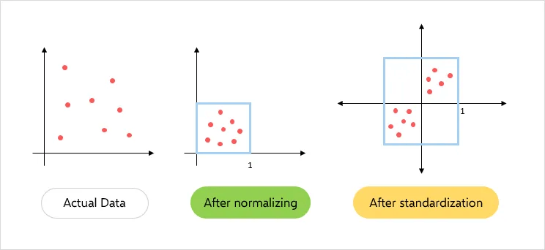
Image Source
In data analysis and machine learning workflows, data normalization is a pre-processing step. It adjusts the scale of data and ensures that all variables in a dataset are on a similar scale. This uniformity is important as it prevents any single variable from overshadowing others.
For machine learning algorithms that rely on distance or gradient-based methods, normalized data is especially key. It helps these algorithms to function optimally and leads to the creation of models that are accurate, reliable, and unbiased. This ultimately enhances the quality of insights derived from the data.

3 Data Normalization Techniques & Formulas
Data analysis and machine learning use several techniques for normalizing data. Let’s discuss the 3 most commonly used methods.

Min-Max Normalization
This technique performs a linear transformation on the original data. Each value is replaced according to a formula that considers the minimum and maximum values of the data. The goal is to scale the data to a specific range, such as [0.0, 1.0]. The formula for min-max normalization is:
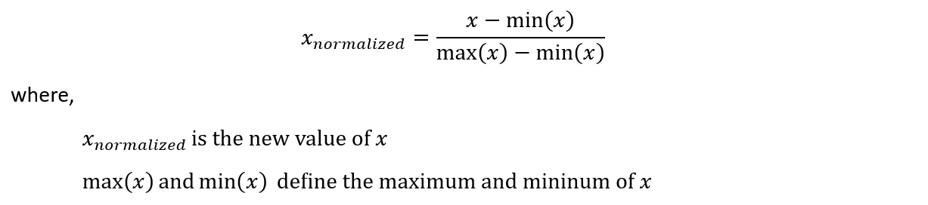

Z-Score Normalization
Also known as Zero mean normalization or standardization, this technique normalizes values based on the mean and standard deviation of the data. Each value is replaced by a score that indicates how many standard deviations it is from the mean. You can apply Z-score normalization using the following formula:
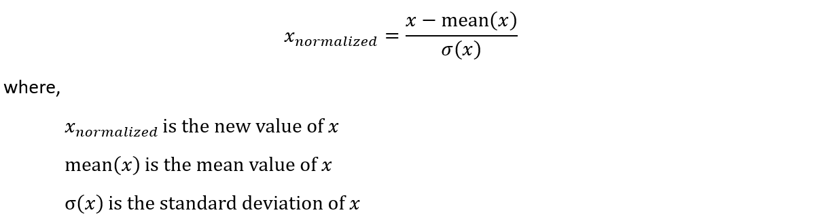

Decimal Scaling Normalization
This technique normalizes by moving the decimal point of values of the data. Each value of the data is divided by the maximum absolute value of the data, resulting in values typically in the range of -1 to 1. The formula for this simple normalization technique is:
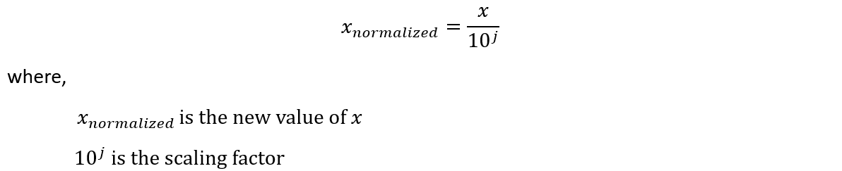

3 Examples Of Data Normalization In Data Analysis & Machine Learning
Let’s apply the normalization techniques discussed above to real-world data. This can help us uncover the tangible effects they have on data transformation. We will use the Iris dataset which is a popular dataset in the field of machine learning. This dataset consists of 150 samples from 3 species of Iris flowers.
Here’s how you can import the data in Python:
from sklearn.datasets import load_iris
import pandas as pd

# Load the Iris dataset
data = load_iris()
x = data['data']
feature_names = data['feature_names']

# Create a DataFrame from the data for better visual representation
df = pd.DataFrame(x, columns=feature_names)
Here’s a sample of the dataset:
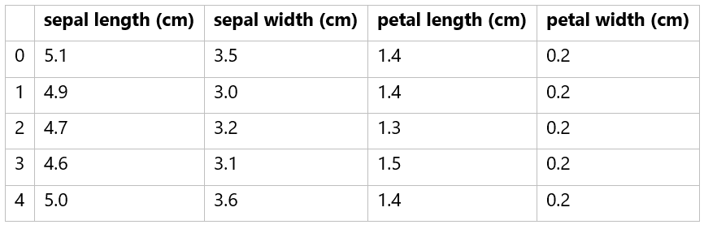

Min-Max Normalization Example
Min-Max normalization is a simple yet effective method to rescale features to a specific range, typically 0 to 1. Here is how you can perform Min-Max normalization using Python and Scikit-learn:
from sklearn.preprocessing import MinMaxScaler

# Create the scaler
scaler = MinMaxScaler()

# Fit and transform the data
df_min_max_scaled = pd.DataFrame(scaler.fit_transform(df), columns=df.columns)
When we apply Min-Max normalization to the Iris dataset, we get:
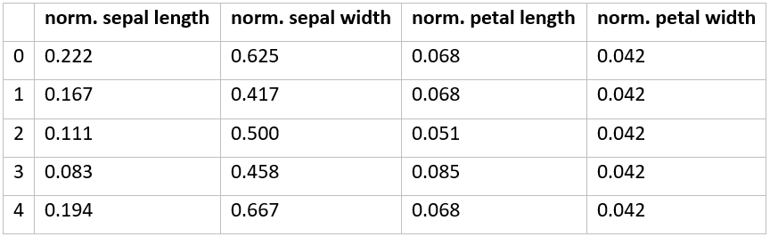

Z-score Normalization Example
Z-score normalization, or standardization, centers the data with a mean of 0 and a standard deviation of 1. Here's an example of how to perform Z-score normalization:
from sklearn.preprocessing importStandardScaler
# Create the scaler
scaler = StandardScaler()

# Fit and transform the data
df_standard_scaled = pd.DataFrame(scaler.fit_transform(df), columns=df.columns)
Z-score normalization of the Iris dataset gives:
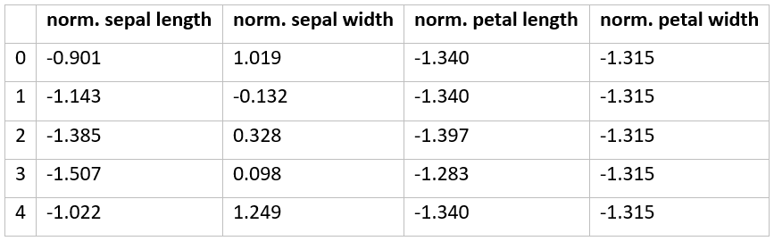

Decimal Scaling Normalization Example
Decimal scaling normalization is particularly useful when the maximum absolute value of a feature is known. Here's a simple Python example of decimal scaling normalization:
import numpy as np

# Perform decimal scaling
max_abs_val = np.max(np.abs(df.values), axis=0)
df_decimal_scaled = df / 10 ** np.ceil(np.log10(max_abs_val))
The decimal scaling normalization code above first checks the order of the largest value in the dataset and then divides the entire dataset by it. Here’s the result:
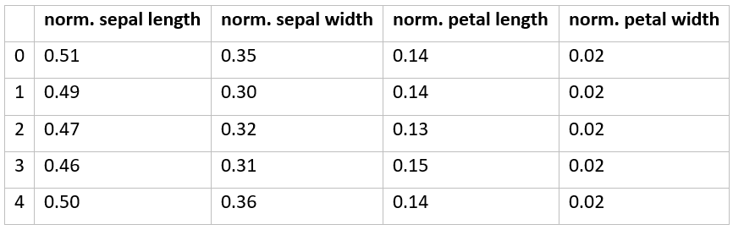
The scales of the features in each of the 3 normalized datasets are much closer to each other than in the original dataset. This helps to ensure that all features contribute equally to the final result.

How Estuary Can Help With Data Normalization
Estuary Flow is a real-time data pipeline platform designed to facilitate the seamless ingestion, integration, and transformation of data in real time. It provides a robust infrastructure that lets users build and manage data pipelines with ease, ensuring that data is always up-to-date and readily available for analysis.
Flow is built on a foundation of open-source technologies and offers a unique approach to data management that combines the best aspects of traditional databases and modern streaming systems. Flow's architecture is designed to handle both batch and real-time data, making it a versatile tool for a wide range of applications.
One of the key ingredients of Flow is its use of collections, which are essentially real-time data lakes of JSON documents stored in cloud storage. These collections can either be captured from an external system or derived as a transformation of one or more other collections. This provides a flexible and efficient way to manage and normalize data.
Here are some of the key features of Flow that can support data normalization:
- Default annotations: It uses default annotations to prevent null values from being materialized to your endpoint system, ensuring data consistency.
- Real-time transformations: Flow supports SQL and Typescript for data manipulation, including functions like AVG(), MIN(), MAX(), and STDDEV() that can be used for data normalization.
- Projections: It uses projections to translate between the documents of a collection and a table representation. This feature is particularly useful when dealing with systems that model flat tables of rows and columns.
- Logical partitions: It allows you to logically partition a collection, isolating the storage of documents by their differing values for partitioned fields. This can help improve the efficiency of data storage and retrieval.
- Real-time data processing: It processes data in real-time which ensures that your normalized data is always up-to-date. This is particularly useful for applications that require immediate insights from the data.
- Reductions: Flow can merge multiple documents with a common key into a single document using customizable reduction strategies.
- Schema management: It uses JSON Schema to define your data’s structure, representation, and constraints. This allows for robust data validation and ensures that your data is clean and valid before it's stored or processed.
- Flexible data ingestion: Flow allows for the ingestion of data from a wide array of sources, including databases, cloud storage, and message queues. This flexibility makes it easier to bring in data from various sources for normalization.

