Introduction of Relational Algebra in DBMS
Last Updated : 23 Jul, 2025

Relational Algebra is a formal language used to query and manipulate relational databases, consisting of a set of operations like selection, projection, union, and join. It provides a mathematical framework for querying databases, ensuring efficient data retrieval and manipulation. Relational algebra serves as the mathematical foundation for query SQL
Relational algebra simplifies the process of querying databases and makes it easier to understand and optimize query execution for better performance. It is essential for learning SQL because SQL queries are based on relational algebra operations, enabling users to retrieve data effectively.
The relational algebra is a theoretical procedural query language which takes an instance of relations and does operations that work on one or more relations to describe another relation without altering the original relation(s). Thus, both the operands and the outputs are relations. So the output from one operation can turn into the input to another operation, which allows expressions to be nested in the relational algebra, just as you nest arithmetic operations. This property is called closure: relations are closed under the algebra, just as numbers are closed under arithmetic operations.
The relational algebra is a relation-at-a-time (or set) language where all tuples are controlled in one statement without the use of a loop. There are several variations of syntax for relational algebra commands, and you use a common symbolic notation for the commands and present it informally.

Key Concepts in Relational Algebra
Before explaining relational algebra operations, let's define some fundamental concepts:
1. Relations: In relational algebra, a relation is a table that consists of rows and columns, representing data in a structured format. Each relation has a unique name and is made up of tuples.
2. Tuples: A tuple is a single row in a relation, which contains a set of values for each attribute. It represents a single data entry or record in a relational table.
3. Attributes: Attributes are the columns in a relation, each representing a specific characteristic or property of the data. For example, in a "Students" relation, attributes could be "Name", "Age", and "Grade".
4. Domains: A domain is the set of possible values that an attribute can have. It defines the type of data that can be stored in each column of a relation, such as integers, strings, or dates.

Basic Operators in Relational Algebra
Relational algebra consists of various basic operators that help us to fetch and manipulate data from relational tables in the database to perform certain operations on relational data. Basic operators are fundamental operations that include selection (σ), projection (π), union (U), set difference (−), Cartesian product (×), and rename (ρ).
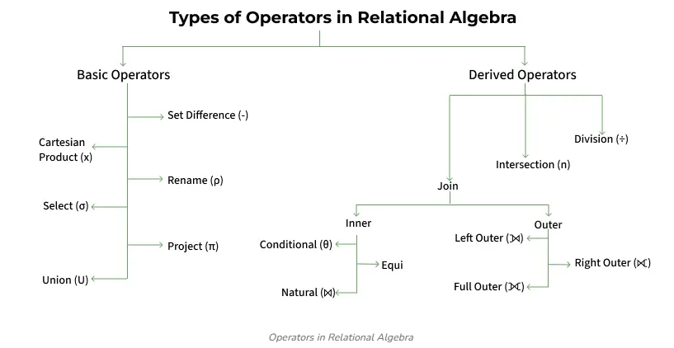

Operators in Relational Algebra

Unary Relational Operations
- SELECT (symbol: σ)
- PROJECT (symbol: π)
- RENAME (symbol: ρ)

Relational Algebra Operations From Set Theory
- UNION (υ)
- INTERSECTION ( ),
- DIFFERENCE (-)
- CARTESIAN PRODUCT ( x )

Binary Relational Operations
- JOIN
- DIVISION

Unary relational operations are operations in relational algebra that involve only one relation (or table) as input. They're fundamental in database theory and are used to manipulate or retrieve data from a single relation without combining it with another.

  - Selection(σ)

The SELECT operation is used for selecting a subset of the tuples according to a given selection condition. Sigma(σ)Symbol denotes it. It is used as an expression to choose tuples which meet the selection condition.

The Selection Operation is basically used to filter out rows from a given table based on certain given condition. It basically allows us to retrieve only those rows that match the condition as per condition passed during SQL Query.
Example: If we have a relation R with attributes A, B, and C, and we want to select tuples where C > 3, we write:
A | B | C
1 | 2 | 4
2 | 2 | 3
3 | 2 | 3
4 | 3 | 4

σ(c>3)(R) will select the tuples which have c more than 3.
Notation − σp(R)
Here σ stands for selection predicate, and R stands for relation, and p is a propositional logic formula which may use connectors like and, or, and not.
σ _{predicate}(R): This selection operation functions on a single relation R and describes a relation that contains only those tuples of R that satisfy the specified condition (predicate).

Output:
A | B | C
1 | 2 | 4
4 | 3 | 4
Explanation: The selection operation only filters rows but does not display or change their order. The projection operator is used for displaying specific columns.

  - Projection(π)

The projection method defines a relation that contains a vertical subset of Relation.

The projection eliminates all attributes of the input relation but those mentioned in the projection list.
While Selection operation works on rows, similarly projection operation of relational algebra works on columns. It basically allows us to pick specific columns from a given relational table based on the given condition and ignoring all the other remaining columns.
Example: Suppose we want columns B and C from Relation R.

π(B,C)(R) will show following columns.
Output:
B | C
2 | 4
2 | 3
3 | 4
Explanation: By Default, projection operation removes duplicate values.

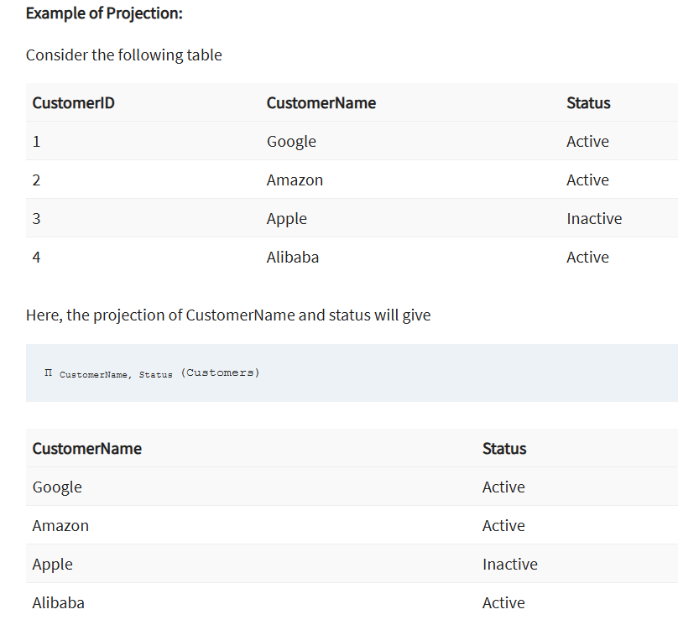

3. Union(U)
The Union Operator is basically used to combine the results of two queries into a single result. The only condition is that both queries must return same number of columns with same data types. Union operation in relational algebra is the same as union operation in set theory.
Example: Consider the following table of Students having different optional subjects in their course.
FRENCH
Student_Name | Roll_Number
Ram | 01
Mohan | 02
Vivek | 13
Geeta | 17
GERMAN
Student_Name | Roll_Number
Vivek | 13
Geeta | 17
Shyam | 21
Rohan | 25
If FRENCH and GERMAN relations represent student names in two subjects, we can combine their student names as follows:
π(Student_Name)(FRENCH) U π(Student_Name)(GERMAN)
Output:
Student_Name
Ram
Mohan
Vivek
Geeta
Shyam
Rohan
Explanation: The only constraint in the union of two relations is that both relations must have the same set of Attributes.
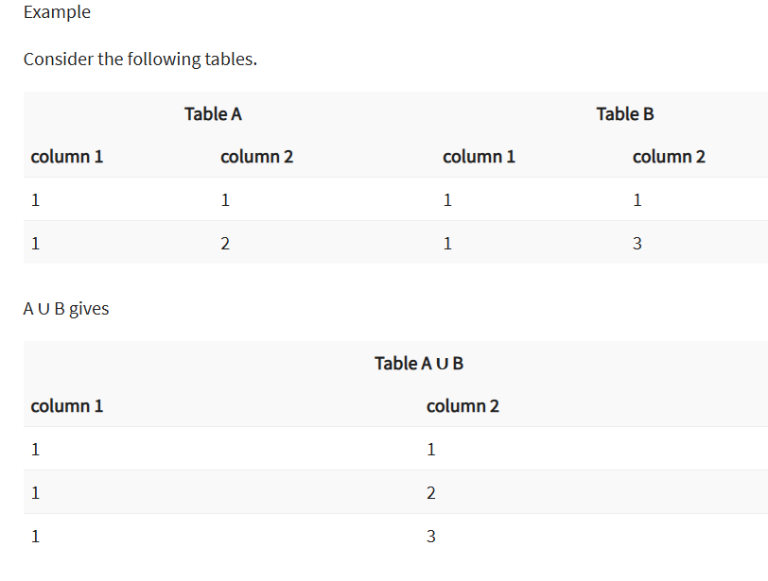
- r and s must have the same quantity of attributes.
- Attribute domains must be compatible.
- Duplicate tuples get automatically eliminated.

Intersection
An intersection is defined by the symbol ∩
A ∩ B

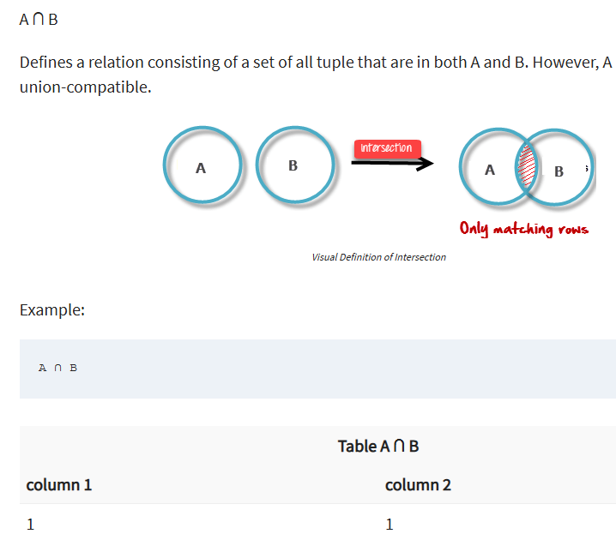

4. Set Difference(-)
Set difference basically provides the rows that are present in one table, but not in another tables. Set Difference in relational algebra is the same set difference operation as in set theory.

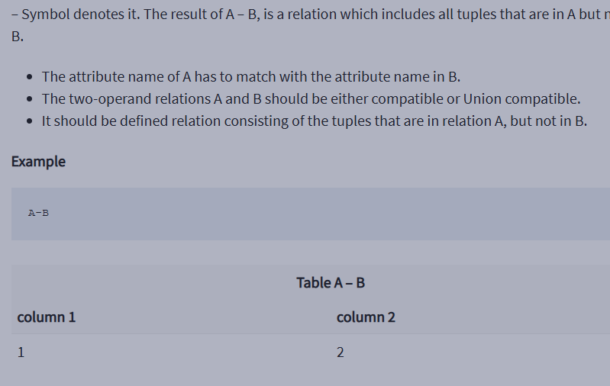

Example: To find students enrolled only in FRENCH but not in GERMAN, we write:
π(Student_Name)(FRENCH) - π(Student_Name)(GERMAN)
Student_Name
Ram
Mohan
Explanation: The only constraint in the Set Difference between two relations is that both relations must have the same set of Attributes.

For R − S The Set difference operation defines a relation consisting of the tuples that are in relation R, but not in S. R and S must be union-compatible.

Relational Algebra in DBMS

5. Rename(ρ)
Rename operator basically allows you to give a temporary name to a specific relational table or to its columns. It is very useful when we want to avoid ambiguity, especially in complex Queries. Rename is a unary operation used for renaming attributes of a relation.
Example: We can rename an attribute B in relation R to D
A | B | C
1 | 2 | 4
2 | 2 | 3
3 | 2 | 3
4 | 3 | 4
ρ(D/B)R will rename the attribute 'B' of the relation by 'D".
Output Table:
A | D | C
1 | 2 | 4
2 | 2 | 3
3 | 2 | 3
4 | 3 | 4

6. Cartesian Product(X)
The Cartesian product combines every row of one table with every row of another table, producing all the possible combination. It's mostly used as a precursor to more complex operation like joins. Let’s say A and B, so the cross product between A X B will result in all the attributes of A followed by each attribute of B. Each record of A will pair with every record of B.
Relation A:
Name | Age | Sex
Ram | 14 | M
Sona | 15 | F
Kim | 20 | M
Relation B:
ID | Course
1 | DS
2 | DBMS
Output: If relation A has 3 rows and relation B has 2 rows, the Cartesian product A × B will result in 6 rows.
Name | Age | Sex | ID | Course
Ram | 14 | M | 1 | DS
Ram | 14 | M | 2 | DBMS
Sona | 15 | F | 1 | DS
Sona | 15 | F | 2 | DBMS
Kim | 20 | M | 1 | DS
Kim | 20 | M | 2 | DBMS

Explanation: If A has 'n' tuples and B has 'm' tuples then A X B will have 'n*m' tuples.

Introduction of Relational Algebra in DBMS - GeeksforGeeks

Derived Operators in Relational Algebra
Derived operators are built using basic operators and include operations like join, intersection, and division. These operators help perform more complex queries by combining basic operations to meet specific data retrieval needs.

1. Join Operators
Join operations in relational algebra combine data from two or more relations based on a related attribute, allowing for more complex queries and data retrieval. Different types of joins include:

Inner Join
An inner join combines rows from two relations based on a matching condition and only returns rows where there is a match in both relations. If a record in one relation doesn't have a corresponding match in the other, it is excluded from the result. This is the most common type of join.
- Conditional Join: A conditional join is an inner join where the matching condition can involve any comparison operator like equals (=), greater than (>), etc. Example: Joining Employees and Departments on DepartmentID where Salary > 50000 will return employees in departments with a salary greater than 50,000
- Equi Join: An equi join is a type of conditional join where the condition is specifically equality (=) between columns from both relations. Example: Joining Customers and Orders on CustomerID where both relations have this column, returning only matching records.
- Natural Join: A natural join automatically combines relations based on columns with the same name and type, removing duplicate columns in the result. It’s a more efficient way of joining. Example: Joining Students and Enrollments where StudentID is common in both, and the result contains only unique columns.

Outer Join
An outer join returns all rows from one relation, and the matching rows from the other relation. If there is no match, the result will still include all rows from the outer relation with NULL values in the columns from the unmatched relation.
- Left Outer Join: A left outer join returns all rows from the left relation and the matching rows from the right relation. If there is no match, the result will include NULL values for the right relation’s attributes. Example: Joining Employees with Departments using a left outer join ensures all employees are listed, even those who aren't assigned to any department, with NULL values for the department columns.
- Right Outer Join: A right outer join returns all rows from the right relation and the matching rows from the left relation. If no match exists, the left relation's columns will contain NULL values. Example: Joining Departments with Employees using a right outer join includes all departments, even those with no employees assigned, filling unmatched employee columns with NULL.
- Full Outer Join: A full outer join returns all rows when there is a match in either the left or right relation. If a row from one relation does not have a match in the other, NULL values are included for the missing side. Example: Joining Customers and Orders using a full outer join will return all customers and orders, even if there’s no corresponding order for a customer or no customer for an order.

2. Set Intersection(∩)
Set Intersection basically allows to fetches only those rows of data that are common between two sets of relational tables. Set Intersection in relational algebra is the same set intersection operation in set theory.
Example: Consider the following table of Students having different optional subjects in their course.
Relation FRENCH
Student_Name | Roll_Number
Ram | 01
Mohan | 02
Vivek | 13
Geeta | 17
Relation GERMAN
Student_Name | Roll_Number
Vivek | 13
Geeta | 17
Shyam | 21
Rohan | 25
From the above table of FRENCH and GERMAN, the Set Intersection is used as follows:
π(Student_Name)(FRENCH ∩ π(Student_Name)(GERMAN)
Output:
Student_Name
Vivek
Geeta
Explanation: The only constraint in the Set Difference between two relations is that both relations must have the same set of Attributes.

3. Division (÷)
The Division Operator is used to find tuples in one relation that are related to all tuples in another relation. It’s typically used for "for all" queries.
Student_Course (Dividend Table):
Student_ID | Course_ID
101 | C1
101 | C2
102 | C1
103 | C1
103 | C2
Course (Divisor Table):
Course_ID
C1
C2
Example: Query is to find students who are enrolled in all courses listed in the Course table. In this case, students must be enrolled in both C1 and C2.
Student_Course(Student_ID, Course_ID)÷ Course(Course_ID)
Output:
Student_ID
101
103

