Data Models in DBMS?
Data models describe how a database’s logical structure is represented. In a database management system, data models are essential for introducing abstraction.
A data model is not just a set of tables; it is a conceptual representation of physical data stored in the database.
A Database Model is a type of data model that defines a Database’s logical structure. It determines how data can be stored, organized, and manipulated in the first place.
Database models are frameworks in database management systems, dictating how data is structured, stored, and accessed
A data model can be defined as an integrated collection of concepts describing and manipulating data, as well as constraints on the data within an organization.
A data model is not just a set of tables; it is a conceptual representation of physical data stored in the database.
A data model in a Database Management System (DBMS) is an abstract representation that defines how data is structured, organized, and related within a database. It provides a conceptual framework for designing and implementing databases, outlining the logical arrangement of data and the connections between different data components.
The Data Model gives us an idea of how the final system would look after it has been fully implemented.
In a database management system, data models are often used to show how data is connected, stored, accessed, and changed.
A Data Model in Database Management System (DBMS) are developed to summarize the description of the database.
Data Models provide us with a transparent picture of data which helps us in creating an actual database.
Data models define how the logical structure of a database is modeled.
Data Models are fundamental entities to introduce abstraction in a DBMS.
Data models define how data is connected to each other and how they are processed and stored inside the system.

Designing a Data Model
what kind of data you want to store in your database. This usually involves defining the entities involved in your application. An entity is any object that exists independently of anything else. You might think about an entity as something like a "person" or an "address."
Once you've identified all the entities, you need to decide how they relate to each other. In most cases, the answer to this question depends on what type of business process you're modelling.
The next step is to figure out how those entities will interact with each other ( means relationships/associations). In some applications, you may want to create a single table to hold all the data about a particular entity.
However, you could also use several tables, where each table holds only part of the data about an individual entity. In addition, you should consider whether you'll need to perform queries across more than one table. If so, you'll probably need to link them together using foreign key columns.
Once you know the basic structure of your data model, you can start thinking about how best to organize it into tables. There are two main approaches: relational databases and hierarchical databases:
- Relational databases are organized around a set of tables that share common fields.
- Hierarchical databases are organized around a tree-like structure called a hierarchy.
Both approaches allow you to build complex structures quickly, but they do so at the cost of flexibility.

Why use Data Models?
Data models are extremely useful for any organization as they let business users directly define core business rules. As a result, fewer revisions are required during implementation. It also leads to significant reductions in development time, allowing businesses to deliver new businesses and projects faster.
Overall, the advantages of using data models can be summed up briefly in the following way:
1. Helps to cut costs and deliver products faster
2. It improves business processes significantly
3. Reduces complexity and risks in data handling
Now, let's discuss the various types of data models in DBMS in detail.

Advantages of Data Models
- Data Models help us in representing data accurately.
- It helps us in finding the missing data and also in minimizing Data Redundancy.
- Data Model provides data security in a better way.
- The data model should be detailed enough to be used for building the physical database.
- The information in the data model can be used for defining the relationship between tables, primary and foreign keys, and stored procedures.

Disadvantages of Data Models
- In the case of a vast database, sometimes it becomes difficult to understand the data model.
- You must have the proper knowledge of SQL to use physical models.
- Even smaller change made in structure require modification in the entire application.
- There is no set data manipulation language in DBMS.
- To develop Data model one should know physical data stored characteristics.

Types of Models/ Types of Data Model in DBMS
There are a variety of models for data. Some of the most well-known models include:
- A Hierarchical model
- Network model
- Model of Entity-Relationship
- Relational Model
- Object-Oriented Data Model
- Object-Relational Data Model

Hierarchical Model

This concept uses a hierarchical tree structure to organise the data. The hierarchy begins at the root, which contains root data, and then grows into a tree as child nodes are added to the parent node.
The Hierarchical Model was the first database management system model.
This concept uses a hierarchical tree structure to organise the data. The hierarchy begins at the root, which contains root data, and then grows into a tree as child nodes are added to the parent node. This model accurately depicts several real-world relationships such as food recipes, website sitemaps, and so on.
- The hierarchical model was developed in the 1960s, primarily driven by the need for efficient data storage and quick data retrieval systems in large-scale information processing, like the systems used by IBM. It was one of the first database models to be created, offering a solution that was more systematic and flexible than the flat file storage systems previously in use.

- The hierarchical database model organizes data into a tree-like structure, with a single root, to which all the other data is linked.
- The hierarchy starts from the Root data, and expands like a tree, adding child nodes to the parent nodes.
- In this model, a child node will only have a single parent node.
- This model efficiently describes many real-world relationships like the index of a book, etc.
- IBM's Information Management System (IMS) is based on this model.
- Data is organized into a tree-like structure with a one-to-many relationship between two different types of data, for example, one department can have many courses, many teachers, and of course many students(like shown in the diagram below).
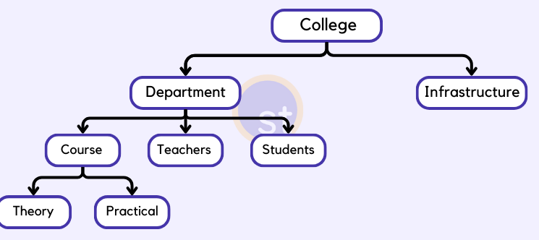
the hierarchical model stands out for its tree-like structure where data is organized in parent-child relationships, resembling a family tree.
This model, significant in the early development of database systems, enables efficient data retrieval through predefined pathways.
Despite its age, the hierarchical model is still pertinent in modern applications that demand rigid hierarchical structures, such as XML data processing and organizational charts.

Its capability to manage complex hierarchies effectively makes it invaluable for specific scenarios where performance and data order are prioritized.
- The hierarchical model is a type of database model that organizes data into a tree-like structure based on parent-child relationships. Each record, or "node," holds data and links to subordinate nodes, establishing a one-to-many relationship from the parent node to its children.
- In a hierarchical database, data is represented visually as a tree. The root node at the top represents the starting point, and branches extend downwards to child nodes, illustrating the relationships and flow of data access.
- Each child node has only one parent but potentially multiple children, creating a strictly defined structure that enhances the speed and simplicity of data navigation.
- This model, while somewhat limited by its rigidity and the complexity of implementing changes to the database structure, was crucial in the evolution of data storage methodologies and still influences modern database architectures that require structured hierarchical data management.

Example
The following diagram depicts the relationship between the shoes available on a shopping website:
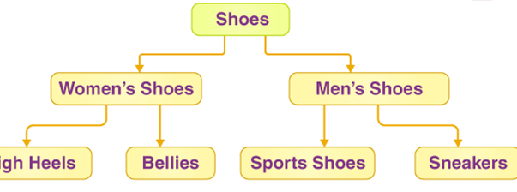

Features of a Hierarchical Model

1. Parent-Child Relationship
A parent node exists for each child node. However, a parent node might have several child nodes. It is not permitted to have more than one parent.

2. One-to-many Relationship
The data is organised in a tree-like form, with the datatypes having a one-to-many relationship. There can only be one path from any node to its parent. For example, in the preceding example, there is only one way to get to the node ‘sneakers’, which is through the ‘men’s shoes’ node.

3. Deletion Problem
When a parent node is removed, the child node is removed as well.

4. Pointers
Pointers are used to connect the parent and child nodes and to traverse and navigate between the stored data. The ‘shoes’ node in the above example points to the two additional nodes, ‘women’s shoes’ and ‘men’s shoes.’

Advantages/pros of Hierarchical Model
Here are a few points to mark the advantages and disadvantages of the Hierarchical database model:
- Because it has one-to-many relationships between different types of data so it is easier and fast to fetch the data.
- A tree-like structure is incredibly straightforward and quick to navigate.
- Any modification to the parent node is reflected automatically in the child node, ensuring data integrity.

Disadvantages / Cons of Hierarchical Model
- But the Hierarchical model is less flexible.
- And it doesn't support many-to-many relationships.
- Relationships that are complex are not supported.
- Because it only supports one parent per child node, if we have a complex relationship in which a child node needs to have two parents, we won’t be able to describe it using this model.
- When a parent node is removed, the child node is removed as well.

Network Model
The main difference between this model and the hierarchical model is that any record can have several parents in the network model.
It uses a graph instead of a hierarchical tree.
The hierarchical model is extended in the network model.
Prior to the relational model, it was the most popular model.
To increase database performance and standards, the network model was devised to express complicated data relationships more effectively than hierarchical models. It has entities that are grouped in a graphical format, and some of the entities can be reached by many paths.
- This model was formalized by the Database Task group in the 1960s.
- This model is the generalization of the hierarchical model.
- This model can consist of multiple parent segments and these segments are grouped as levels but there exists a logical association between the segments belonging to any level.
- Mostly, there exists a many-to-many logical association between any of the two segments.
- We called graphs the logical associations between the segments. Therefore, this model replaces the hierarchical tree with a graph-like structure,
- many-to-many which allows a record to have more than one parent segment.
- Here, a relationship is called a set, and each set is made up of at least 2 types of record which are given below:
- An owner record that is the same as of parent in the hierarchical model.
- A member record that is the same as of child in the hierarchical model.

Structure of a Network Model
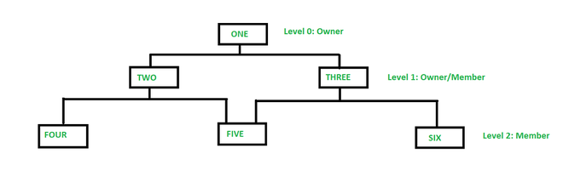
- In the above figure, member TWO has only one owner 'ONE' whereas member FIVE has two owners i.e, TWO and THREE. Here, each link between the two record types represents 1 : M relationship between them.

- it allows 1: 1, 1 : M, M : N relationships among the given entities which helps in avoiding data redundancy problems as it supports multiple paths to the same record.

Example : Network model for a Finance Department.
Below we have designed the network model for a Finance Department:
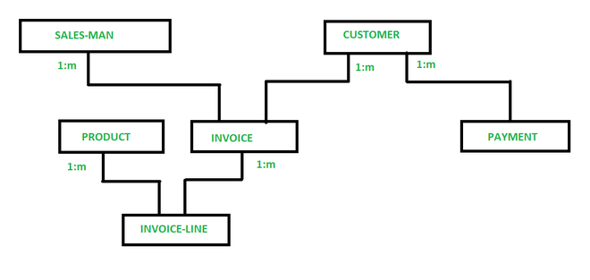Network model of Finance Department.
So, in a network model, a one-to-many (1: N) relationship has a link between two record types. Now, in the above figure, SALES-MAN, CUSTOMER, PRODUCT, INVOICE, PAYMENT, INVOICE-LINE are the types of records for the sales of a company. Now, as you can see in the given figure, INVOICE-LINE is owned by PRODUCT & INVOICE. INVOICE has also two owners SALES-MAN & CUSTOMER.
Let's see another example, in which we have two segments, Faculty and Student. Say that student John takes courses both in CS and EE departments. Now, find how many instances will be there?
For the above example, a student's instance can have at least 2 parent instances therefore, there exist relations between the instances of students and faculty segment. The model can be very complex as if we use other segments say Courses and logical associations like Student-Enroll and Faculty-course. So, in this model, a student can be logically associated with various instances of Faculties and Courses.

- The Network Model is an extension of the Hierarchical model.
- In this model, data is organized more like a graph, and allowed to have more than one parent node.
- In the network database model, data is more related as more relationships are established in this database model.
- Also, as the data is more related, hence accessing the data is also easier and fast.
- This database model uses many-to-many data relationships.
- Integrated Data Store (IDS) is based on this database model.
- This was the most widely used database model before Relational Model was introduced.
- The implementation of the Network model is complex, and it's very difficult to maintain it.
- The Network model is difficult to modify also.
- You may want to explore this if you are developing some social networking applications, although the Graph Database model is new and is far better than the Network Database model.

Example
We can observe that the node student has two parents, CSE Department and Library, in the example below. In the hierarchical model, this was previously impossible.
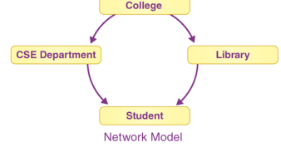

Features of a Network Model

Multiple Paths
There may be several paths to the same record due to the increased number of relationships. It allows for quick and easy data access.

The Ability to Merge More Relationships (not one to many)
Data is more connected in this model since there are more relationships. This paradigm can handle many-to-many as well as one-to-one relationships.
- Data Relationship Representation: The network model uses a graph structure to represent data relationships. It allows many-to-many relationships, providing greater flexibility in how data is connected.
- Records and Sets: Data in a network model is organized into records and sets. Records are similar to rows in a relational table, and sets are used to define relationships between records, akin to links in a graph.
- Owner-Member Relationships: The network model defines data relationships using owner-member pairs. An owner record can be linked to multiple member records, and a member record can belong to multiple owner records, facilitating complex relationships.
- Navigational Access: The network model supports navigational data access, where records are accessed through predefined paths. This is different from relational models, which use declarative query languages like SQL.
- Hierarchical and Non-Hierarchical Structures: The network model can represent both hierarchical (tree-like) and non-hierarchical (graph-like) structures, providing flexibility in data modeling.

Circular Linked List
The circular linked list is used to perform operations on the network model. The present position is kept up to date with the help of a software, and it navigates through the records based on the relationship.

Pros of Network Model/ Advantages of the Network Model
- It supports complex relationships
- It allows more flexibility
- In comparison to the hierarchical model, data can be retrieved faster. This is because the data in the network model is more related, and there may be more than one path to a given node. As a result, the data can be accessed in a variety of ways.
- Data integrity is present since there is a parent-child relationship. Any changes to the parent record are mirrored in the child record.
- Hierarchical and Non-Hierarchical Structures: The network model can represent both hierarchical (tree-like) and non-hierarchical (graph-like) structures, providing flexibility in data modeling.

Cons of Network Model
- As the number of relationships to be managed grows, the system may get increasingly complicated. To operate with the model, a user must have a thorough understanding of it.
- Any alteration, such as an update, deletion, or insertion, is extremely difficult.
- Pointers need storage (too many pointers)

Operations on Network Model in DBMS
- Insertion: Adding new records and establishing owner-member relationships.
- Deletion: Removing records and maintaining data integrity by handling related records and relationships.
- Update: Modifying existing records and relationships between records.
- Traversal: Navigating through the network structure to access related records using predefined paths.
- Search: Retrieving specific records based on criteria by navigating the network structure.

Difference Between the Network Model and the Hierarchical Model
Feature | Hierarchical Model | Network Model
Structure | Tree-like structure | Graph structure
Relationships | One-to-many (single parent, multiple children) | Many-to-many (multiple parents and children)
Flexibility | Less flexible | More flexible
Data Access | Single access path | Multiple access paths
Redundancy | Higher redundancy due to rigid hierarchy | Lower redundancy due to shared relationships
Complexity | Simpler to design and implement | More complex to design and manage
Usage Scenario | Suitable for simple, hierarchical data structures | Suitable for complex, interconnected data structures
Efficiency | Efficient for hierarchical traversal | Efficient for complex queries and data retrieval
Example | Organizational chart | Telecommunications network

Entity-Relationship Model
The real-world problem is depicted in visual form in this model to make it easier for stakeholders to comprehend.
The ER diagram also makes it very simple for developers to comprehend the system.
Entity-Relationship (ER) Model is based on the notion of real-world entities and relationships among them. While formulating real-world scenario into the database model, the ER Model creates entity set, relationship set, general attributes and constraints.
ER Model is best used for the conceptual design of a database.
- In this database model, relationships are created by dividing objects of interest into entities and their characteristics into attributes.
- Different entities are related using relationships.
- ER Models are defined to represent the relationships in pictorial form to make it easier for different stakeholders to understand.
- This model is good to design a database, which can then be turned into tables in a relational model (explained below).
- Let's take an example, If we have to design a School Database, then the Student will be an entity with attributes name, age, address, etc. As an Address is generally complex, it can be another entity with attributes street, pincode, city, etc, and there will be a relationship between them.
- Relationships can also be of different types. You can learn about ER Diagrams in detail if you want to learn about entities and relationships.
ER Model is based on −
- Entities and their attributes.
- Relationships among entities.
These concepts are explained below.
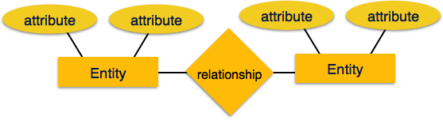
- Entity − An entity in an ER Model is a real-world entity having properties called attributes. Every attribute is defined by its set of values called domain. For example, in a school database, a student is considered as an entity. Student has various attributes like name, age, class, etc.
- Relationship − The logical association among entities is called relationship. Relationships are mapped with entities in various ways. Mapping cardinalities define the number of association between two entities.
Mapping cardinalities −
  - one to one
  - one to many
  - many to one
  - many to many

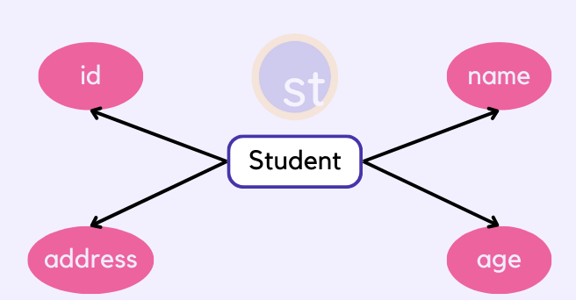

Advantages of the ER Model
- It is easy to understand and design.
- Using the ER model we can represent data structures easily.
- As the ER model cannot be directly implemented into a database model, it is just a step toward designing the relational database model.

Relational Model
The most popular data model in DBMS is the Relational Model. It is more scientific a model than others. This model is based on first-order predicate logic and defines a table as an n-ary relation.
The main highlights of this model are −
- Data is stored in tables called relations.
- Relations can be normalized.
- In normalized relations, values saved are atomic values.
- Each row in a relation contains a unique value.
- Each column in a relation contains values from a same domain.

- In this model, data is organized in two-dimensional tables and the relationship is maintained by storing a common field.
- This model was introduced by E.F Codd in 1970, and since then it has been the most widely used database model.
- The basic structure of data in the relational model is tables. All the information related to a particular type is stored in rows of that table.
- Hence, tables are also known as relations in the relational model.
- You can design tables, normalize them to reduce data redundancy, and use Structured Query language or SQL to access data from the tables.
- Some of the most popular databases are based on this database model. For example, Oracle, MySQL, etc.
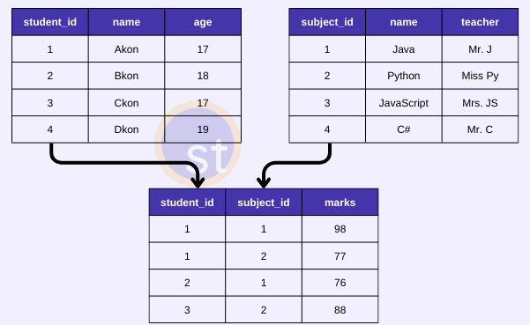
Advantages of the Relational Model
- It's simple and easy to implement.
- Poplar database software is available for this database model.
- It supports SQL using which you can easily query the data.
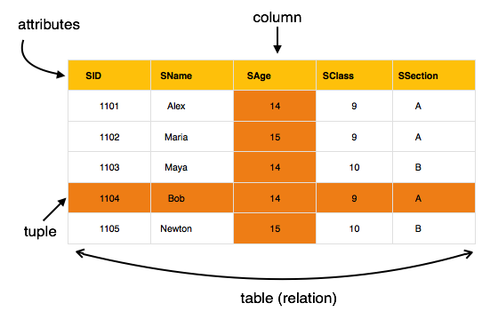
Just for go through if required
First-order predicate logic is a formal system used to express statements about objects and their relationships using quantifiers, variables, predicates, and logical connectives. It allows reasoning about properties of individuals and the connections between them within a defined domain.
If you'd like, I can also provide a bilingual version or a compact slide-ready definition for your students.
Core Components of First-Order Predicate Logic
Component | Description
Constants | Specific objects in the domain (e.g., a, b, John, 5)
Variables | Symbols that can represent any object (e.g., x, y, z)
Predicates | Functions that return true/false about objects (e.g., Student(x))
Functions | Map objects to other objects (e.g., MotherOf(x))
Quantifiers | Express generality: ∀ (for all), ∃ (there exists)
Logical Connectives | ∧ (and), ∨ (or), ¬ (not), → (implies), ↔ (iff)
Domain of Discourse | The set of objects being discussed (e.g., all students in a class)
✍️ Example Statements in FOPL
- "All students are enrolled in some course."
\forall x \, (Student(x) \rightarrow \exists y \, Course(y) \land Enrolled(x, y))
- "There exists a student who is not enrolled in any course."
\exists x \, (Student(x) \land \forall y \, (Course(y) \rightarrow \neg Enrolled(x, y)))

Object-oriented Model

The need for a data model that more accurately matched the real world became apparent as real-world problems became more complicated.

Both data and the data relationships are stored into a single structure that’s known as an object in the object-oriented data model (or OODM). The object-oriented DMS (or Data Management System) is built on top of the OODM (OODBMS).
- in this model, data is stored in the form of objects.
- The behavior of the object-oriented database model is just like object-oriented programming.
- A very popular example of an Object Database management system or ODBMS is MongoDB which is also a NoSQL database.
- This database model is not mature enough as compared to the relational database model.
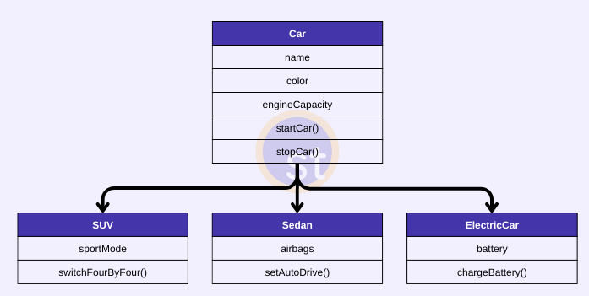
- The OODM is a better representation of real-world challenges. Both the data and the relationship are contained into a single structure that’s known as an object in this model. We can now store audios, pictures, videos, and other types of data in databases, which was previously impossible with the relational approach (Although you can store video and audio in relational DB, it is generally advised not to store them in the relational DB).

Need of Object Oriented Data Model :
To represent the complex real world problems there was a need for a data model that is closely related to real world. Object Oriented Data Model represents the real world problems easily.
Object Oriented Data Model :
In Object Oriented Data Model, data and their relationships are contained in a single structure which is referred as object in this data model. In this, real world problems are represented as objects with different attributes. All objects have multiple relationships between them.
Components of Object Oriented Data Model :
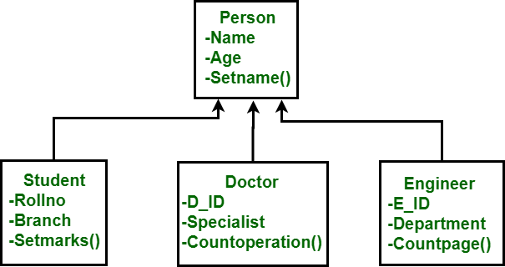Basic Object Oriented Data Model

- Objects -
An object is an abstraction of a real world entity or we can say it is an instance of class. Objects encapsulates data and code into a single unit which provide data abstraction by hiding the implementation details from the user. For example: Instances of student, doctor, engineer in above figure.
- Attribute -
An attribute describes the properties of object. For example: Object is STUDENT and its attribute are Roll no, Branch, Setmarks() in the Student class.
- Methods -
Method represents the behavior of an object. Basically, it represents the real-world action. For example: Finding a STUDENT marks in above figure as Setmarks().
- Class -
A class is a collection of similar objects with shared structure i.e. attributes and behavior i.e. methods. An object is an instance of class. For example: Person, Student, Doctor, Engineer in above figure.
class student
{
char Name[20];
int roll_no;
--
--
public:
void search();
void update();
}
In this example, students refers to class and S1, S2 are the objects of class which can be created in main function.
- Inheritance -
By using inheritance, new class can inherit the attributes and methods of the old class i.e. base class. For example: as classes Student, Doctor and Engineer are inherited from the base class Person.

Examples
Here is an example of this model:
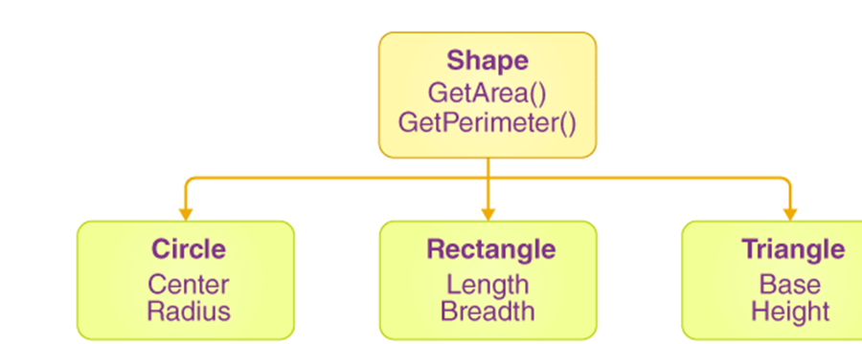
Multiple objects are connected in this model using connections. The following example can help you understand this.
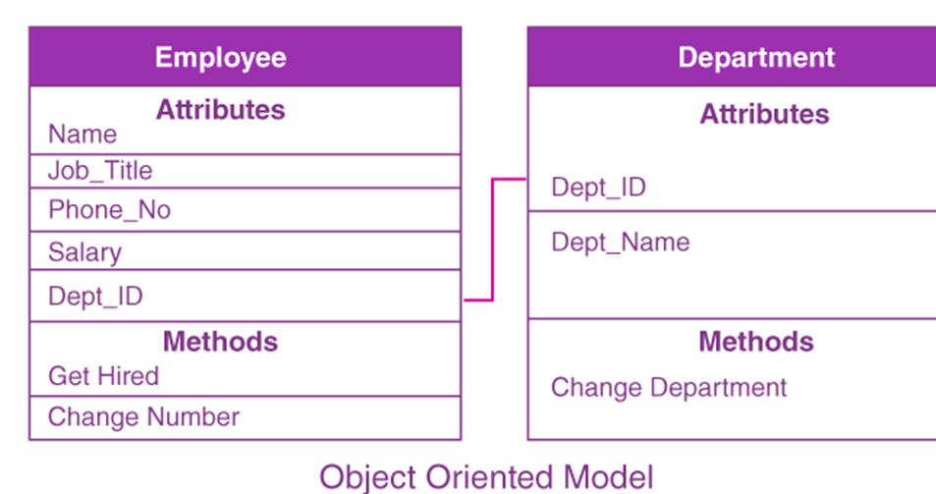
The Employee and Department are the two objects in the example above. Each object’s data and the relationships are there in a single unit. Here, the attributes of the employee, such as Name and Job_title, as well as the methods that will be performed by that object, are all kept in a single object. The two objects are linked by a common attribute, i.e., Department_id, as well as communication between them will be accomplished by this common id.

Components of an Object-Oriented Data Model
• An object is a representation of a physical entity. In general, an object can be thought of as the entity of an ER model. A single instance of an entity is represented by an object.
• An object’s attributes are described by attributes. For example, the properties Social Security Number, Name, and Date of Birth are all present in a PERSON object.
• Classes are groups of objects with similar features. A class is a group of objects that have similar structure (attributes) and behaviour (methods). A class is similar to the entity set in the ER model in general. A class, on the other hand, differs from an entity set. It has a collection of procedures called methods. The method of a class depicts a real-world activity like finding a PERSON’s name, updating a PERSON’s name, printing a PERSON’s address, and many more. In other words, in classical programming languages, the methods are equivalent to procedures. Methods define the behaviour of an object in OO terms.
• A class hierarchy is used to organise classes. The class hierarchy in some ways resembles an upside-down tree with only one parent for each class. The CUSTOMER and EMPLOYEE classes, for example, have the same parent PERSON class. (Notice how this is comparable with the hierarchical data model).
• Inheritance refers to an object’s capacity to inherit the characteristics and methods of those classes that are above it in the class hierarchy. For instance, two classes can be built as subclasses of the PERSON class: CUSTOMER and EMPLOYEE. EMPLOYEE and CUSTOMER will inherit all properties and methods from PERSON in this situation.
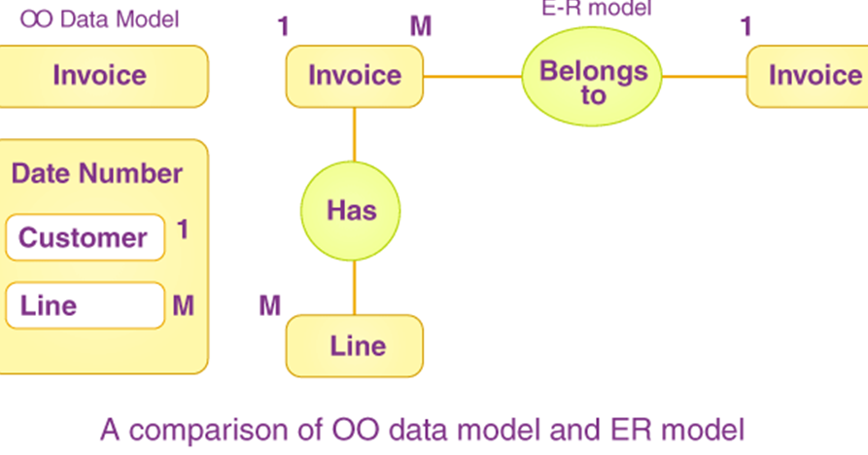
Advantages of Object Oriented Data Model :
- Codes can be reused due to inheritance.
- Easily understandable.
- Cost of maintenance can reduced due to reusability of attributes and functions because of inheritance.
- It can easily support complex data structures, with relationships.
- It also supports features like Inheritance, Encapsulation, etc.
Disadvantages of Object Oriented Data Model :
- It is not properly developed so not accepted by users easily.

6. NoSQL Model
- The NoSQL database model supports an unstructured style of storing data.
- Data is stored as documents.
- The documents look more like JSON strings or Key-value based object representations.
- It provides a flexible schema.
- It does provide features like indexing, relationships between data, etc.
- The support for data querying is limited in the NoSQL database model.
- This database model is well-suited for Big data applications, real-time analytics, CMS (Content Management systems), etc.
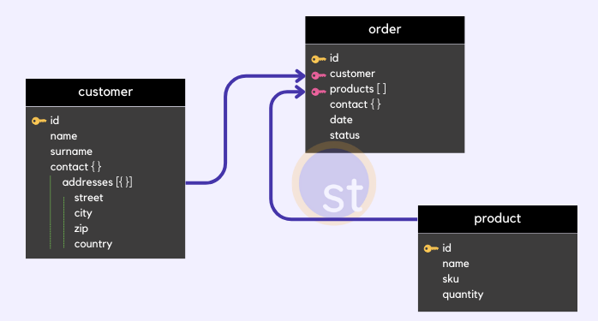

Advantages of the NoSQL Model
- This database model is scalable.
- This database model functions with high performance.
- The NoSQL database model can handle large volumes of data.

Object-Relational Data Model in DBMS
Basically, it is combination of Object Oriented programming and Relational Database Model as it is clear from the following figure :
= Combination of Object Oriented Programming + Relational database model

- The Object-Relational data model refers to a combination of a Relational database model and an Object-Oriented database model.
- As a result, it supports classes, objects, inheritance, and other features found in Object-Oriented models, as well as data types, tabular structures, and other features found in Relational Data Models.
- It combines the relational and Object-Oriented models, as the name implies.
- This model was developed to bridge the gap between the Object-Oriented and relational models.
- Many additional capabilities are available, such as the ability to create complicated data types based on our requirements utilising existing data types. The issue with this paradigm is that it can become overly complicated and difficult to manage. As a result, a thorough comprehension of the model is essential.
One of the main goals of the Object-Relational data model is to bridge the gap between Object-Oriented practices and the Relational databases common in programming languages like C++, C#, and Java.

History
Both relational as well as Object-Oriented data models are extremely beneficial. However, it was determined that they both lacked certain traits; therefore, work began on creating a model that combined the two. As a result of research conducted in the 1990s, this data model was developed.

Pros- Object-Relational Data Model
The following are some of the benefits of the Object-Relational model:

Inheritance
Users of this data model can inherit objects, tables, and other data to expand their capability. Inherited objects have new properties in addition to those that were inherited.

Complex Data Types
Existing data types can be used to create complex data types. This is useful in the Object-Relational data model because complex data types allow for more effective data manipulation.

Extensibility
In the Object-Relational data model, the system’s capability can be expanded. This can be accomplished through the use of complicated data types and advanced Object-Oriented concepts such as inheritance.

Cons- Object-Relational Data Model
Because it combines the features of both the Object-Oriented data model and the Relational data model, this data model can be rather complicated and hard to handle at times.

