### Emergence of Software Engineering

The field of software engineering emerged from a growing crisis in the 1960s, often referred to as the "software crisis." As computers became more powerful and prevalent, the complexity of the software being developed skyrocketed. Projects were frequently behind schedule, over budget, and failed to meet user requirements. The software produced was often unreliable, difficult to maintain, and prone to errors. This was largely because software development was treated more like an art or a craft than a rigorous engineering discipline.

#### The "Software Crisis" and its Causes

In the early days of computing, programmers often worked in isolation, writing code without much formal structure. This approach was manageable for simple programs but became unsustainable as applications grew in size and complexity. The primary issues that fueled the software crisis were:

* **Cost and Schedule Overruns:** Projects consistently exceeded their original budgets and timelines.
* **Low-Quality and Unreliable Software:** The final products were often buggy, insecure, and not robust enough for critical applications.
* **Poor Maintainability:** Software was difficult to modify or fix because it lacked clear documentation and a logical, modular structure.
* **Lack of Standardization:** There was no common methodology or set of best practices for building software.

#### The Birth of the Discipline

The term "software engineering" was first coined at a NATO Science Committee conference in Garmisch, Germany, in 1968. The purpose of this conference was to address the challenges of the software crisis head-on. The attendees, which included leading computer scientists and industry experts, recognized that a more systematic, disciplined, and quantifiable approach was needed. They argued that software development should adopt principles from established engineering fields, such as civil or mechanical engineering, to build reliable and efficient systems.

This marked a pivotal shift in mindset. Instead of focusing solely on writing code, the new discipline emphasized a structured process that included:

* **Formal Requirements Analysis:** Clearly defining what the software should do before any code is written.
* **Structured Design and Architecture:** Creating a blueprint for the system to ensure it is robust and scalable.
* **Rigorous Testing and Quality Assurance:** Implementing systematic methods to verify and validate the software.
* **Project Management:** Applying established management techniques to control costs, schedules, and resources.

#### Key Early Developments

The years following the 1968 conference saw the development of many foundational concepts and tools that are still in use today:

* **Structured Programming:** Pioneered by Edsger Dijkstra, this approach advocated for using logical control structures (like if-then-else and while loops) to write clearer, more maintainable code.
* **Waterfall Model:** One of the first software development life cycle models, it provided a linear, sequential approach from requirements to maintenance. While its limitations are now well-known, it was a crucial step toward a more disciplined process.
* **Object-Oriented Programming (OOP):** The concept of objects and classes, which encapsulate data and behavior, provided a powerful new way to manage complexity and create reusable code.
* **Version Control Systems:** Tools like RCS and later CVS were created to track and manage changes to source code, enabling collaborative development.

**Evolution of Software Engineering: From an Art To Engineering Discipline**

Software Engineering is a systematic and cost-effective technique for software development. It is an engineering approach to developing software.

**For example:**If someone wants to travel from Punjab to Delhi. There are two approaches one can follow to achieve the same result:

1. The normal approach is to go out and catch the bus/train that is available.
2. A systematic approach is constructed as Firstly check on Google Maps distance and after analyzing the timing of trains and buses online that, match the user's preference suppose the user has some work till 4:00 PM and train slots are: 1:00 PM, 6:00 PM then the user will choose 6:00 PM time slot and reach Delhi.

From the above situation, one can easily analyze that Creating a systematic Approach is more optimal, time, and cost-effective than a normal approach. This will occur while designing Software. So in Software Engineering working on an Engineering or a Systematic approach is more beneficial.

**Evolution of Software Engineering**

[Software engineering](https://www.geeksforgeeks.org/software-engineering/software-engineering-introduction-to-software-engineering/) has evolved from being considered an art to becoming a recognized engineering discipline. In the early days of computing, software development was primarily done by individuals or small teams who wrote code based on their own experiences and knowledge. This approach was often referred to as "hacking" or "programming by intuition." As the field of computing grew, it became apparent that this approach was not sustainable and that a more structured and systematic approach was needed.

In the 1960s and 1970s, the field of software engineering began to take shape. Researchers and practitioners began to develop formal methods for software design and development, such as structured programming and the use of flowcharts to represent algorithms. In 1968, a conference on software engineering was held, and the term "software engineering" was officially coined.

In the following decades, software engineering continued to evolve and mature. The introduction of object-oriented programming in the 1980s led to a shift in how software was designed and developed. The 1990s saw the emergence of the Agile software development methodologies, which emphasized flexibility and responsiveness to change. Today, software engineering is a well-established field with its own set of best practices, methodologies, and tools. It is considered as a discipline of engineering and follows the same principles like any other engineering field.

In summary, software engineering has evolved from an art to a discipline with its own set of best practices, methodologies, and tools. The field has grown and matured over time, with new technologies and approaches being developed to improve the design and development of software.

**Is Software Engineering A Science Or An Art?**

Most people think that writing a good quality program is an Art. So let's discuss it as an Art or Science. Like other engineering, branches suppose Mechanical engineering. It is based on Science where there are specific rules and names for each component, technique, and working principle related to it and before they are standardized the experience is marked as their thumb rule and on the basis of it, the rules are standardized by various organizations. Similarly, in Software Engineering there is heavy use of knowledge which is gathered from the experience of practitioners. Thus, various Organizations or Researchers's made systematically organized the experience of practitioners in the theoretical form. Before these are standardized, the experience act as Thumb Rule. Thus, like every other Engineering Discipline,  Software Engineering is a Science that is transformed from an Art.

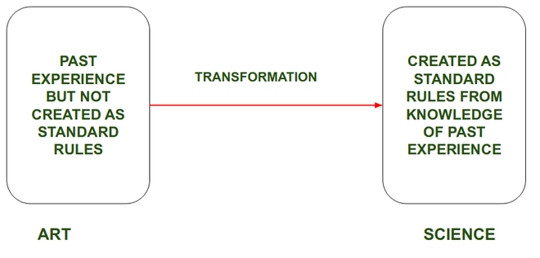

**Software Engineering Evolution: From An Art To Engineering Discipline**

Software Engineering principles have evolved over the last sixty years with the contributions of various researchers and software professionals. From the beginning period Software Engineering acts as an Art after that with time, it transformed into a craft and finally to Engineering Discipline.  
Initially, Programmers used an *Ad Hoc*programming style. *Ad Hoc*programming is an approachable solution in an unplanned or unorganized manner. In this type of Programming Style, no plan is created on how to create Structure and Steps to complete the programming task but without having any systematic approach the problem needs to be solved in the required time. This style is now referred to as exploratory, build and fix, and code and fix styles.  
Like in today's world various researchers and scientists working on those things which are not even necessary but during the initial period, Programmers worked on those things which are really needed. But as time fleet the Ad Hoc Programming will cause various problems which results in less efficiency and another approach i.e. systematic approach is adopted.

Let us get started with the detailed step-by-step process of the evolution of software engineering. The following steps are discussed:

1. Software engineering as an art
2. Software engineering transition from art to craft
3. Software engineering transition from craft to an engineering discipline

**Software Engineering As An Art**

Software Engineering as an Art means, this can be only learned by specific people and other people's are not allowed to work on them.

* Software engineering as an art refers to the creative and intuitive aspect of software development. It involves the use of creativity, problem-solving skills, and artistic expression to design and develop software systems that are not only functional but also aesthetically pleasing and user-friendly.
* In the early days of software development, many programmers considered software development as an art, as it was more about creativity and intuition than about following a set of established processes and methodologies. Programmers would often write code in an ad-hoc manner, without much structure or planning, and the final product was often the result of their personal artistic expression.
* However, as software systems have become more complex and important, it has become clear that the traditional ad-hoc approach to software development is not sufficient. This has led to the emergence of the field of software engineering, which has focused on bringing more structure and discipline to the software development process.
* Despite this, the art of software engineering still plays an important role in the development process. For example, a good software engineer must also have a sense of aesthetics, be able to think creatively and out of the box and be able to develop software that is easy to use and understand.

**For Example:**In ancient times only a few people know Gold Ornaments making. Those who know Gold Ornaments making kept it as a secret and will reveal to his genetic generation. So at this time, this is known as Art and during that time accuracy was very less.  
The same in Software Development, only a few people know about Software designing and coding and at that time there is no set of rules or instruction for software designing. And those who are able to write code efficiently and essentially fix bugs are considered proficient and those who are not good at programming and didn't know about that were left wondering that how they could effortlessly write elegant and correct code each time.  
Like Gold Ornaments are not efficiently designed in the same way Program Coding is not efficiently done due to this various issues cause which degrades the efficiency of Software but at time efficiency is not considered as an important aspect.

**oftware Engineering Transition from Art to Craft**

Software Engineering transformed from Art to Craft when the area of people who know Software Designing and Coding will increase.

The transition of software engineering from an art to a craft can be seen as a gradual process that has occurred over time.

* In the early days of software development, software engineering was primarily considered an art form. Programmers would often write code in an ad-hoc manner, without much structure or planning, and the final product was often the result of their personal artistic expression.
* As software systems have become more complex and important, it has become clear that the traditional ad-hoc approach to software development is not sufficient. This led to the emergence of the field of software engineering, which focused on bringing more structure and discipline to the software development process.
* With the emergence of software engineering as a discipline, the focus shifted from the artistic expression of individual programmers to the use of established processes and methodologies to ensure the quality and reliability of software systems. This led to the development of new methodologies and techniques such as the Waterfall and Agile methodologies, as well as the development of new tools and technologies to support software development.
* As a result, software engineering has transitioned from an art form to a craft. Instead of relying on the creativity and intuition of individual programmers, software development has become more structured and disciplined, with a focus on using established processes and methodologies to ensure the quality and reliability of software systems.

**For Example:**When the secret of Gold Ornaments making is revealed to the only generation after generation which will increase the number of people in that Art and will convert art into a craft where accuracy is increased.  
The same in Software Engineering, the Specific Degree and P.H.D were introduced in the Universities and some specific people will go further to learn and there is a certain rule which must be fulfilled to take that degree. So the number of people which increases in that area, and they start researching about it and create Standards and Styles for Coding and Software Development which must be followed and these Standards will help to create a less error-free software.

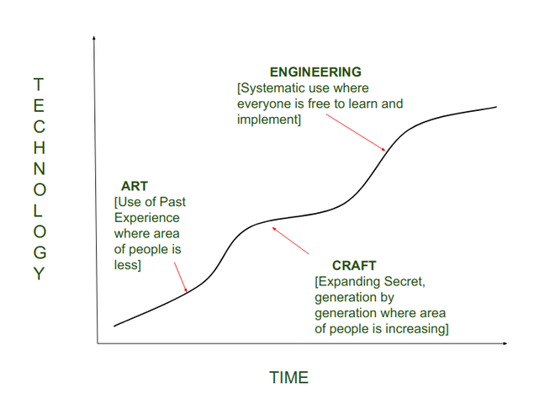

Like gold, ornaments are taking decent shapes and become efficient. In the same way, Program Writing has also become efficient in terms of Code reusability and efficiency but still, it is at times, efficiency is not considered an important aspect.     **Software Engineering Transition From Craft To Engineering Discipline**

The transition of software engineering from a craft to an engineering discipline can be seen as a gradual process that has occurred over time as the field has matured.

* In the early days of software development, software engineering was considered a craft, with a focus on using established processes and methodologies to ensure the quality and reliability of software systems. However, as the field has grown and matured, software engineering has become more formalized and structured, with the development of new methodologies, techniques and tools to support software development.
* One of the key milestones in the transition of software engineering from a craft to an engineering discipline was the publication of the book "Software Engineering: A Practitioner's Approach" by Pressman in 1975. This book provided a comprehensive overview of the field and defined software engineering as an engineering discipline.
* With the growing recognition of software engineering as an engineering discipline, the focus has shifted from the use of established processes and methodologies to ensure the quality and reliability of software systems, to a more scientific and systematic approach to software development.
* This has led to the development of new techniques and methodologies such as formal methods, model-driven development, and software architecture, which are based on sound scientific principles and are designed to ensure the quality and reliability of software systems.
* In conclusion, software engineering has transitioned from being considered a craft to being considered an engineering discipline as the field has matured and grown more formalized and structured. The field has shifted its focus from relying on established processes and method  
  In today's world Software Engineering acts as an Engineering Discipline when everyone can learn Software designing and coding irrespective of that they are pursuing a degree or not.  
  **For example:**In today's world everyone can learn Gold Ornament making and accuracy has much more increased with the help of various machines. Also, it is converted into a Professional study where people will learn about how? Why? The science behind it etc.  
  The same in software engineering occur where everyone can learn about Software Development with or without pursuing any Professional Studies and accuracy of Software Development increased with the help of Standards and improved rules created by researchers.  
  Software engineering principles are now widely used in industry and new principles are still continuing to emerge at a very rapid rate.

**Benefits to treating software development as an engineering discipline**

There are many benefits to treating software development as an engineering discipline. Some of the key benefits include:

1. **Improved quality**: By following established best practices and methodologies, software engineers are able to produce higher quality software that is more reliable and less prone to errors.
2. **Increased productivity**: Formal methods and tools can help software engineers work more efficiently and effectively, leading to increased productivity.
3. **Greater predictability**: By following a structured and systematic approach, software engineers can make more accurate predictions about the time and resources required to complete a project.
4. **Better communication**: Software engineering practices can help ensure that all stakeholders, including developers, managers, and clients, have a clear understanding of the project's goals and requirements.
5. **Greater maintainability**: Software engineering practices can help ensure that the software is designed in a way that makes it easy to maintain and update over time.
6. **Better cost management**: By following established best practices and methodologies, software engineers can reduce the cost of development, testing and maintenance of software.
7. **Better Scalability:** Software engineering provides the process and methodologies to design the software in a way that it is easy to scale up or down as per the requirement.

**Important Points to software Engineering Evolution: From An Art To Engineering Discipline**

Following are some important points:

1. Software engineering has evolved from being considered an art form to being considered an engineering discipline.
2. The transition from art to craft involved bringing more structure and discipline to the software development process.
3. The transition from craft to engineering discipline involved a more formalized and structured approach, with a focus on using established
4. processes and methodologies to ensure the quality and reliability of software systems.
5. Key milestones in this transition include the publication of the book "Software Engineering: A Practitioner's Approach" and the development of new methodologies, techniques, and tools to support software development.
6. The goal of software engineering is to deliver a functional, reliable, maintainable, and efficient software.