Display Processor:

It is interpreter or piece of hardware that converts display processor code into pictures. It is one of the four main parts of the display processor

Parts of Display Processor

1. Display File Memory
2. Display Processor
3. Display Generator
4. Display Console

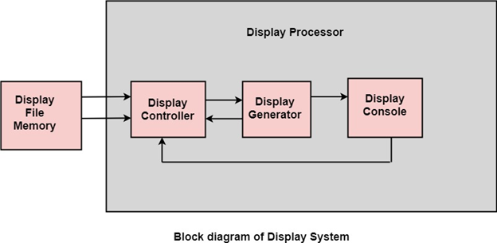

**Display File Memory:** It is used for generation of the picture. It is used for identification of graphic entities.

**Display Controller:**

1. It handles interrupt
2. It maintains timings
3. It is used for interpretation of instruction.

**Display Generator:**

1. It is used for the generation of character.
2. It is used for the generation of curves.

**Display Console:** It contains CRT, Light Pen, and Keyboard and deflection system.

The raster scan system is a combination of some processing units. It consists of the control processing unit (CPU) and a particular processor called a display controller. Display Controller controls the operation of the display device. It is also called a video controller.

**Working:** The video controller in the output circuitry generates the horizontal and vertical drive signals so that the monitor can sweep. Its beam across the screen during raster scans.

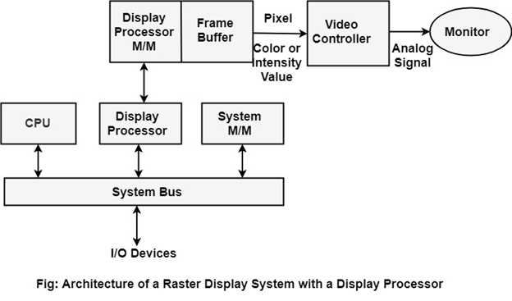

As fig showing that 2 registers (X register and Y register) are used to store the coordinate of the screen pixels. Assume that y values of the adjacent scan lines increased by 1 in an upward direction starting from 0 at the bottom of the screen to ymax at the top and along each scan line the screen pixel positions or x values are incremented by 1 from 0 at the leftmost position to xmax at the rightmost position.

The origin is at the lowest left corner of the screen as in a standard Cartesian coordinate system.

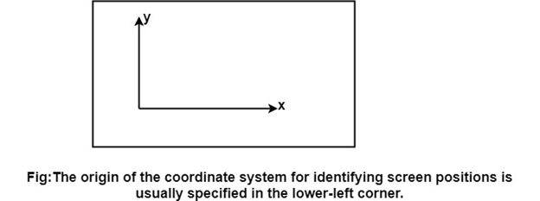

At the start of a **Refresh Cycle**:

X register is set to 0 and y register is set to ymax. This (x, y') address is translated into a memory address of frame buffer where the color value for this pixel position is stored.

The controller receives this color value (a binary no) from the frame buffer, breaks it up into three parts and sends each element to a separate Digital-to-Analog Converter (DAC).

These voltages, in turn, controls the intensity of 3 e-beam that are focused at the (x, y) screen position by the horizontal and vertical drive signals.

This process is repeated for each pixel along the top scan line, each time incrementing the X register by Y.

As pixels on the first scan line are generated, the X register is incremented throughxmax.

Then x register is reset to 0, and y register is decremented by 1 to access the next scan line.

Pixel along each scan line is then processed, and the procedure is repeated for each successive scan line units pixels on the last scan line (y=0) are generated.

For a display system employing a color look-up table frame buffer value is not directly used to control the CRT beam intensity.

It is used as an index to find the three pixel-color value from the look-up table. This lookup operation is done for each pixel on every display cycle.

As the time available to display or refresh a single pixel in the screen is too less, accessing the frame buffer every time for reading each pixel intensity value would consume more time what is allowed:

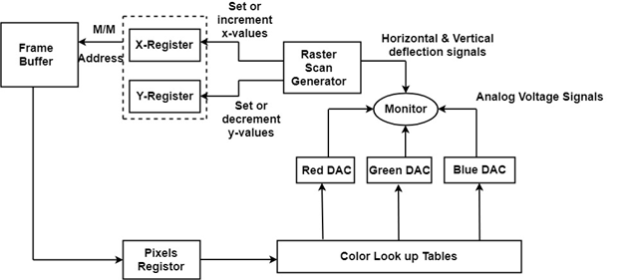

Multiple adjacent pixel values are fetched to the frame buffer in single access and stored in the register.

After every allowable time gap, the one-pixel value is shifted out from the register to control the warm intensity for that pixel.

The procedure is repeated with the next block of pixels,and so on, thus the whole group of pixels will be processed.

Display Devices:

The most commonly used display device is a video monitor. The operation of most video monitors based on CRT (Cathode Ray Tube). The following display devices are used:

1. Refresh Cathode Ray Tube
2. Random Scan and Raster Scan
3. Color CRT Monitors
4. Direct View Storage Tubes
5. Flat Panel Display
6. Lookup Table

Cathode Ray Tube (CRT):

CRT stands for Cathode Ray Tube. CRT is a technology used in traditional computer monitors and televisions. The image on CRT display is created by firing electrons from the back of the tube of phosphorus located towards the front of the screen.

Once the electron heats the phosphorus, they light up, and they are projected on a screen. The color you view on the screen is produced by a blend of red, blue and green light.

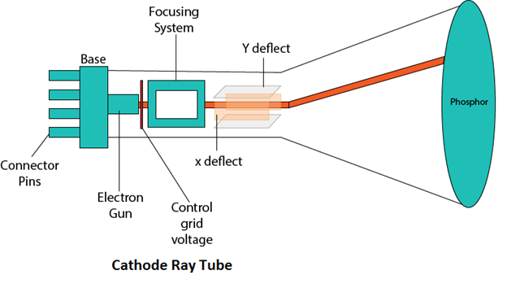

Components of CRT:

Main Components of CRT are:

**1. Electron Gun:** Electron gun consisting of a series of elements, primarily a heating filament (heater) and a cathode. The electron gun creates a source of electrons which are focused into a narrow beam directed at the face of the CRT.

**2. Control Electrode:** It is used to turn the electron beam on and off.

**3. Focusing system:** It is used to create a clear picture by focusing the electrons into a narrow beam.

**4. Deflection Yoke:** It is used to control the direction of the electron beam. It creates an electric or magnetic field which will bend the electron beam as it passes through the area. In a conventional CRT, the yoke is linked to a sweep or scan generator. The deflection yoke which is connected to the sweep generator creates a fluctuating electric or magnetic potential.

**5. Phosphorus-coated screen:** The inside front surface of every CRT is coated with phosphors. Phosphors glow when a high-energy electron beam hits them. Phosphorescence is the term used to characterize the light given off by a phosphor after it has been exposed to an electron beam.

# Random Scan and Raster Scan Display:

## Random Scan Display:

Random Scan System uses an electron beam which operates like a pencil to create a line image on the CRT screen. The picture is constructed out of a sequence of straight-line segments. Each line segment is drawn on the screen by directing the beam to move from one point on the screen to the next, where its x & y coordinates define each point. After drawing the picture. The system cycles back to the first line and design all the lines of the image 30 to 60 time each second. The process is shown in fig:

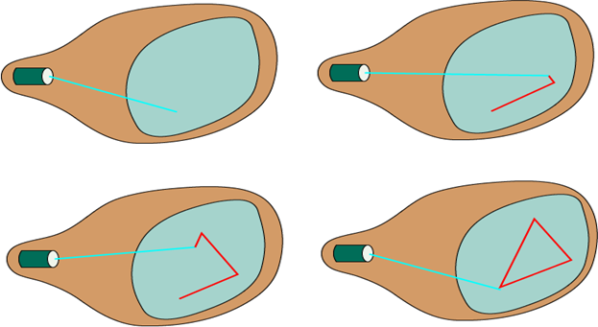

Random-scan monitors are also known as vector displays or stroke-writing displays or calligraphic displays.

## Advantages:

1. A CRT has the electron beam directed only to the parts of the screen where an image is to be drawn.
2. Produce smooth line drawings.
3. High Resolution

## Disadvantages:

1. Random-Scan monitors cannot display realistic shades scenes.

## Raster Scan Display:

A Raster Scan Display is based on intensity control of pixels in the form of a rectangular box called Raster on the screen. Information of on and off pixels is stored in refresh buffer or Frame buffer. Televisions in our house are based on Raster Scan Method. The raster scan system can store information of each pixel position, so it is suitable for realistic display of objects. Raster Scan provides a refresh rate of 60 to 80 frames per second.

Frame Buffer is also known as Raster or bit map. In Frame Buffer the positions are called picture elements or pixels. Beam refreshing is of two types. First is horizontal retracing and second is vertical retracing. When the beam starts from the top left corner and reaches the bottom right scale, it will again return to the top left side called at vertical retrace. Then it will again more horizontally from top to bottom call as horizontal retracing shown in fig:

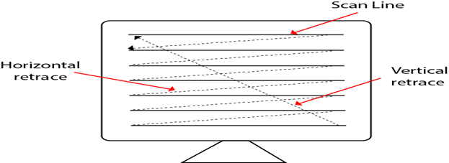

**Types of Scanning or travelling of beam in Raster Scan**

1. Interlaced Scanning
2. Non-Interlaced Scanning

In Interlaced scanning, each horizontal line of the screen is traced from top to bottom. Due to which fading of display of object may occur. This problem can be solved by Non-Interlaced scanning. In this first of all odd numbered lines are traced or visited by an electron beam, then in the next circle, even number of lines are located.

For non-interlaced display refresh rate of 30 frames per second used. But it gives flickers. For interlaced display refresh rate of 60 frames per second is used.

### Advantages:

1. Realistic image
2. Million Different colors to be generated
3. Shadow Scenes are possible.

### Disadvantages:

1. Low Resolution
2. Expensive

## Differentiate between Random and Raster Scan Display:

|  |  |
| --- | --- |
| **Random Scan** | **Raster Scan** |
| 1. It has high Resolution | 1. Its resolution is low. |
| 2. It is more expensive | 2. It is less expensive |
| 3. Any modification if needed is easy | 3.Modification is tough |
| 4. Solid pattern is tough to fill | 4.Solid pattern is easy to fill |
| 5. Refresh rate depends or resolution | 5. Refresh rate does not depend on the picture. |
| 6. Only screen with view on an area is displayed. | 6. Whole screen is scanned. |
| 7. Beam Penetration technology come under it. | 7. Shadow mark technology came under this. |
| 8. It does not use interlacing method. | 8. It uses interlacing |
| 9. It is restricted to line drawing applications | 9. It is suitable for realistic display. |