.

Introduction of Computer Graphics

Computer Graphics involves technology to access. The Process transforms and presents information in a visual form. The role of computer graphics insensible. In today life, computer graphics has now become a common element in user interfaces, T.V. commercial motion pictures.

Computer Graphics is the creation of pictures with the help of a computer. The end product of the computer graphics is a picture it may be a business graph, drawing, and engineering.

In computer graphics, two or three-dimensional pictures can be created that are used for research. Many hardware devices algorithm has been developing for improving the speed of picture generation with the passes of time. It includes the creation storage of models and image of objects. These models for various fields like engineering, mathematical and so on.

Today computer graphics is entirely different from the earlier one. It is not possible. It is an interactive user can control the structure of an object of various input devices.

Definition of Computer Graphics:

It is the use of computers to create and manipulate pictures on a display device. It comprises of software techniques to create, store, modify, represents pictures.

Why computer graphics used?

Suppose a shoe manufacturing company want to show the sale of shoes for five years. For this vast amount of information is to store. So a lot of time and memory will be needed. This method will be tough to understand by a common man. In this situation graphics is a better alternative. Graphics tools are charts and graphs. Using graphs, data can be represented in pictorial form. A picture can be understood easily just with a single look.

Interactive computer graphics work using the concept of two-way communication between computer users. The computer will receive signals from the input device, and the picture is modified accordingly. Picture will be changed quickly when we apply command.

# Interactive and Passive Graphics

## (a) Non-Interactive or Passive Computer Graphics:

In non-interactive computer graphics, the picture is produced on the monitor, and the user does not have any controlled over the image, i.e., the user cannot make any change in the rendered image. One example of its Titles shown on T.V.

Non-interactive Graphics involves only one-way communication between the computer and the user, User can see the produced image, and he cannot make any change in the image.

## (b) Interactive Computer Graphics:

In interactive Computer Graphics user have some controls over the picture, i.e., the user can make any change in the produced image. One example of it is the ping-pong game.

Interactive Computer Graphics require two-way communication between the computer and the user. A User can see the image and make any change by sending his command with an input device.

### Advantages:

1. Higher Quality
2. More precise results or products
3. Greater Productivity
4. Lower analysis and design cost
5. Significantly enhances our ability to understand data and to perceive trends.

## Working of Interactive Computer Graphics:

The modern graphics display is very simple in construction. It consists of three components:

1. Frame Buffer or Digital Memory
2. A Monitor likes a home T.V. set without the tuning and receiving electronics.
3. **Display Controller or Video Controller:** It passes the contents of the frame buffer to the monitor.

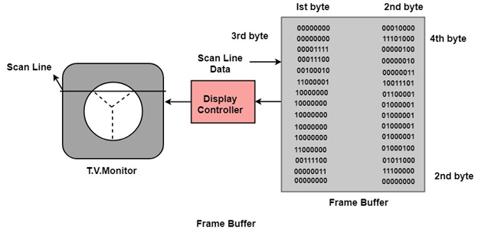

**Frame Buffer:** A digital frame buffer is large, contiguous piece of computer memory used to hold or map the image displayed on the screen.

* At a minimum, there is 1 memory bit for each pixel in the raster. This amount of memory is called a bit plane.
* A 1024 x 1024 element requires 220 (210=1024;220=1024 x 1024)sq.raster or 1,048,576 memory bits in a single bit plane.
* The picture is built up in the frame buffer one bit at a time.
* ∵ A memory bit has only two states (binary 0 or 1), a single bit plane yields a black and white (monochrome display).
* As frame buffer is a digital device write raster CRT is an analog device.